PROIECT SISTEME DE GESTIUNE A BAZELOR DE DATE

-Firma de jocuri video Duca-

De Sumurduc Alexandru

Contents

1.Prezentati pe scurt baza de date (utilitatea ei). 2

2. Realizati diagrama entitate-relatie (ERD): entitatile, relatiile si atributele trebuie definite in limba româna (vezi curs SGBD / model de diagrama ERD; nu se va accepta alt format). 2

3. Pornind de la diagrama entitate-relatie realizati diagrama conceptuala a modelului propus, integrând toate atributele necesare: entitatile, relatiile si atributele trebuie definite in limba româna. 3

4. Implementati in Oracle diagrama conceptuala realizata: definiti toate tabelele, definind toate constrângerile de integritate necesare (chei primare, cheile externe etc). 3

5. Adaugati informatii coerente in tabelele create (minim 5 inregistrari pentru fiecare entitate independenta; minim 10 inregistrari pentru tabela asociativa). 7

6. Formulati in limbaj natural o problema pe care sa o rezolvati folosind un subprogram stocat independent care sa utilizeze toate cele 3 tipuri de colectii studiate. Apelati subprogramul. 16

7. Formulati in limbaj natural o problema pe care sa o rezolvati folosind un subprogram stocat independent care sa utilizeze 2 tipuri diferite de cursoare studiate, unul dintre acestea fiind cursor parametrizat, dependent de celalalt cursor. Apelati subprogramul. 19

8. Formulati in limbaj natural o problema pe care sa o rezolvati folosind un subprogram stocat independent de tip functie care sa utilizeze intr-o singura comanda SQL 3 dintre tabelele definite. Definiti minim 2 exceptii proprii. Apelati subprogramul astfel incât sa evidentiati toate cazurile definite si tratate. 21

9. Formulati in limbaj natural o problema pe care sa o rezolvati folosind un subprogram stocat independent de tip procedura care sa utilizeze intr-o singura comanda SQL 5 dintre tabelele definite. Tratati toate exceptiile care pot aparea, incluzând exceptiile NO_DATA_FOUND si TOO_MANY_ROWS. Apelati subprogramul astfel incât sa evidentiati toate cazurile tratate. 26

10. Definiti un trigger de tip LMD la nivel de comanda. Declansati trigger-ul. 30

11. Definiti un trigger de tip LMD la nivel de linie. Declansati trigger-ul. 32

12. Definiti un trigger de tip LDD. Declansati trigger-ul. 35

13. Definiti un pachet care sa contina toate obiectele definite in cadrul proiectului. 38

14. Definiti un pachet care sa includa tipuri de date complexe si obiecte necesare unui flux de actiuni integrate, specifice bazei de date definite (minim 2 tipuri de date, minim 2 functii, minim 2 proceduri). 40

# 1.Prezentati pe scurt baza de date (utilitatea ei).

Compania de jocuri video „Duca” creeaza , publica jocuri video.Un joc video este creeat cu mai multe software-uri.Promovarea si stocarea produselor se face prin intermediul departamentului de vanzari. Jocurilor se foloesec de servere care se afla pe anumite regiuni.

Dezvoltatori se pot folosi de toate software-rurile oferite de firma.Departamentul juridic se ocupa de aspectele legale ale fimei. Departamentul de vanzari se ocupa de stocarea locatiilor si promovarea jocurilor pe anumite platforme.Resursele umane se ocupa cu resolvarea tichetelor care apar.

# 2. Realizati diagrama entitate-relatie (ERD): entitatile, relatiile si atributele trebuie definite in limba româna (vezi curs SGBD / model de diagrama ERD; nu se va accepta alt format).

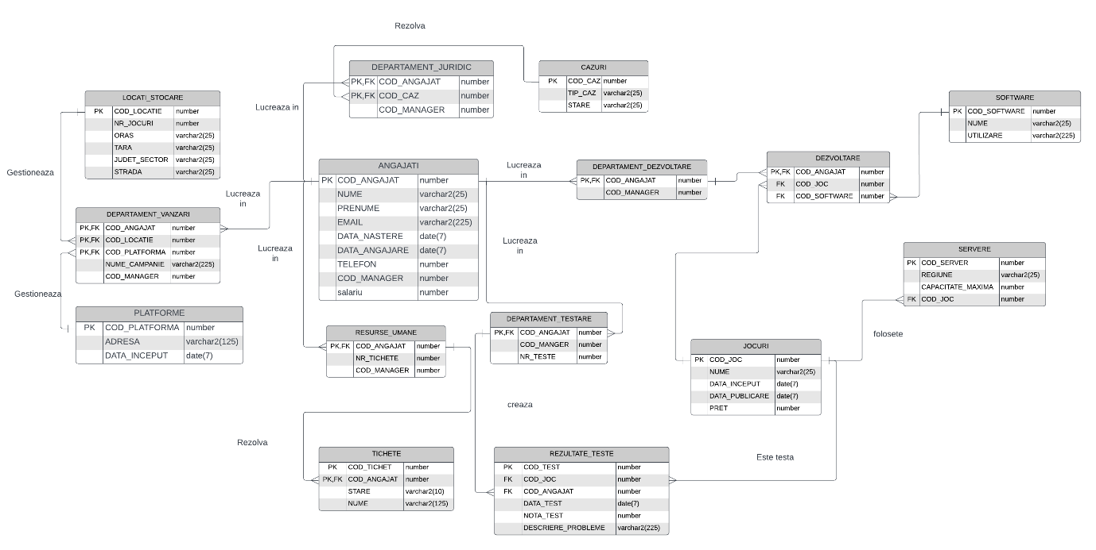

# 3. Pornind de la diagrama entitate-relatie realizati diagrama conceptuala a modelului propus, integrând toate atributele necesare: entitatile, relatiile si atributele trebuie definite in limba româna.

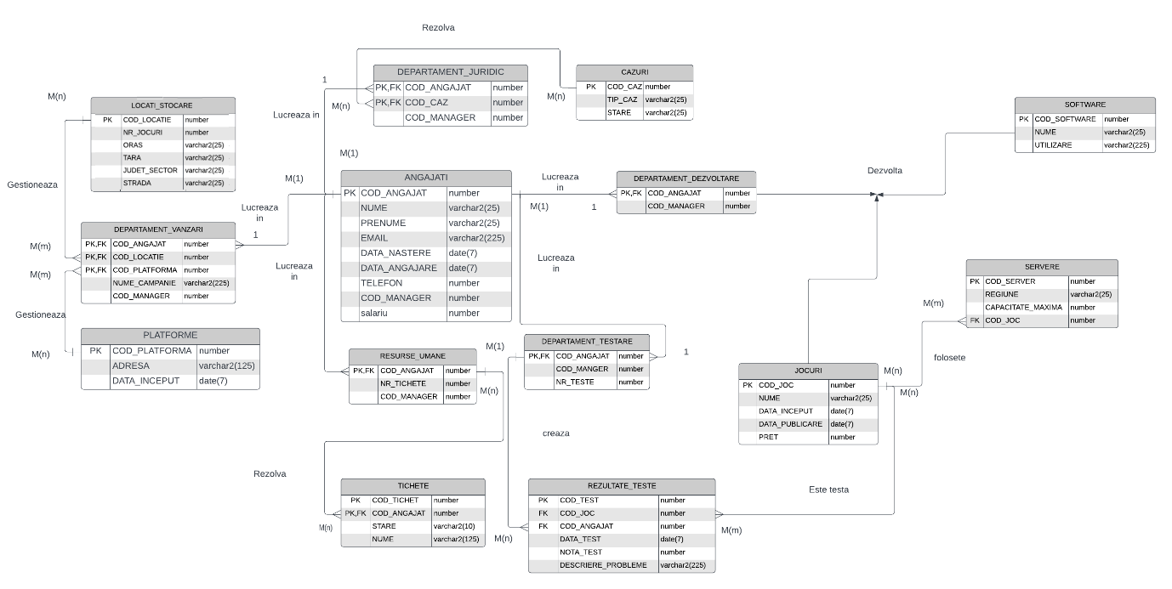

# 4. Implementati in Oracle diagrama conceptuala realizata: definiti toate tabelele, definind toate constrângerile de integritate necesare (chei primare, cheile externe etc).

--6

CREATE TABLE ANGAJATI (

COD_ANGAJAT number,

NUME varchar2(25),

PRENUME varchar2(25),

EMAIL varchar2(225),

DATA_NASTERE date,

DATA_ANGAJARE date,

TELEFON number,

COD_MANAGER number,

salariu number,

PRIMARY KEY (COD_ANGAJAT)

);

CREATE TABLE DEPARTAMENT_DEZVOLTARE (

COD_ANGAJAT number,

COD_MANAGER number,

PRIMARY KEY (COD_ANGAJAT),

FOREIGN KEY (COD_ANGAJAT) REFERENCES ANGAJATI(COD_ANGAJAT)

);

CREATE TABLE CAZURI (

COD_CAZ number,

TIP_CAZ varchar2(25),

STARE varchar2(25),

PRIMARY KEY (COD_CAZ)

);

CREATE TABLE DEPARTAMENT_JURIDIC (

COD_ANGAJAT number,

COD_CAZ number,

COD_MANAGER number,

PRIMARY KEY (COD_ANGAJAT, COD_CAZ),

FOREIGN KEY (COD_ANGAJAT) REFERENCES ANGAJATI(COD_ANGAJAT),

FOREIGN KEY (COD_CAZ) REFERENCES CAZURI(COD_CAZ)

);

CREATE TABLE JOCURI (

COD_JOC number,

NUME varchar2(25),

DATA_INCEPUT date,

DATA_PUBLICARE date,

PRET number,

PRIMARY KEY (COD_JOC)

);

CREATE TABLE SOFTWARE (

COD_SOFTWARE number,

NUME varchar2(25),

UTILIZARE varchar2(225),

PRIMARY KEY (COD_SOFTWARE)

);

CREATE TABLE SERVERE (

COD_SERVER number,

REGIUNE varchar2(25),

CAPACITATE_MAXIMA number,

COD_JOC number,

PRIMARY KEY (COD_SERVER),

FOREIGN KEY (COD_JOC) REFERENCES JOCURI(COD_JOC)

);

CREATE TABLE PLATFORME (

COD_PLATFORMA number,

ADRESA varchar2(125),

DATA_INCEPUT date,

PRIMARY KEY (COD_PLATFORMA)

);

CREATE TABLE DEPARTAMENT_TESTARE (

COD_ANGAJAT number,

COD_MANGER number,

NR_TESTE number,

PRIMARY KEY (COD_ANGAJAT),

FOREIGN KEY (COD_ANGAJAT) REFERENCES ANGAJATI(COD_ANGAJAT)

);

CREATE TABLE REZULTATE_TESTE (

COD_TEST number,

COD_JOC number,

COD_ANGAJAT number,

DATA_TEST date,

NOTA_TEST number,

DESCRIERE_PROBLEME varchar2(225),

PRIMARY KEY (COD_TEST),

FOREIGN KEY (COD_JOC) REFERENCES JOCURI(COD_JOC),

FOREIGN KEY (COD_ANGAJAT) REFERENCES DEPARTAMENT_TESTARE(COD_ANGAJAT)

);

CREATE TABLE LOCATI_STOCARE (

COD_LOCATIE number,

NR_JOCURI number,

ORAS varchar2(25),

TARA varchar2(25),

JUDET_SECTOR varchar2(25),

STRADA varchar2(25),

PRIMARY KEY (COD_LOCATIE)

);

CREATE TABLE DEPARTAMENT_VANZARI (

COD_ANGAJAT number,

COD_LOCATIE number,

COD_PLATFORMA number,

NUME_CAMPANIE varchar2(225),

COD_MANAGER number,

PRIMARY KEY (COD_ANGAJAT, COD_LOCATIE, COD_PLATFORMA),

FOREIGN KEY (COD_ANGAJAT) REFERENCES ANGAJATI(COD_ANGAJAT),

FOREIGN KEY (COD_LOCATIE) REFERENCES LOCATI_STOCARE(COD_LOCATIE),

FOREIGN KEY (COD_PLATFORMA) REFERENCES PLATFORME(COD_PLATFORMA)

);

CREATE TABLE RESURSE_UMANE (

COD_ANGAJAT number,

NR_TICHETE number,

COD_MANAGER number,

PRIMARY KEY (COD_ANGAJAT),

FOREIGN KEY (COD_ANGAJAT) REFERENCES ANGAJATI(COD_ANGAJAT)

);

CREATE TABLE TICHETE (

COD_TICHET number,

COD_ANGAJAT number,

STARE varchar2(10),

NUME varchar2(125),

PRIMARY KEY (COD_TICHET, COD_ANGAJAT),

FOREIGN KEY (COD_ANGAJAT) REFERENCES RESURSE_UMANE(COD_ANGAJAT)

);

CREATE TABLE DEZVOLTARE (

COD_ANGAJAT number,

COD_JOC number,

COD_SOFTWARE number,

PRIMARY KEY (COD_ANGAJAT,COD_JOC,COD_SOFTWARE),

FOREIGN KEY (COD_ANGAJAT )REFERENCES DEPARTAMENT_DEZVOLTARE(COD_ANGAJAT),

FOREIGN KEY (COD_JOC) REFERENCES JOCURI(COD_JOC),

FOREIGN KEY (COD_SOFTWARE) REFERENCES SOFTWARE(COD_SOFTWARE)

);

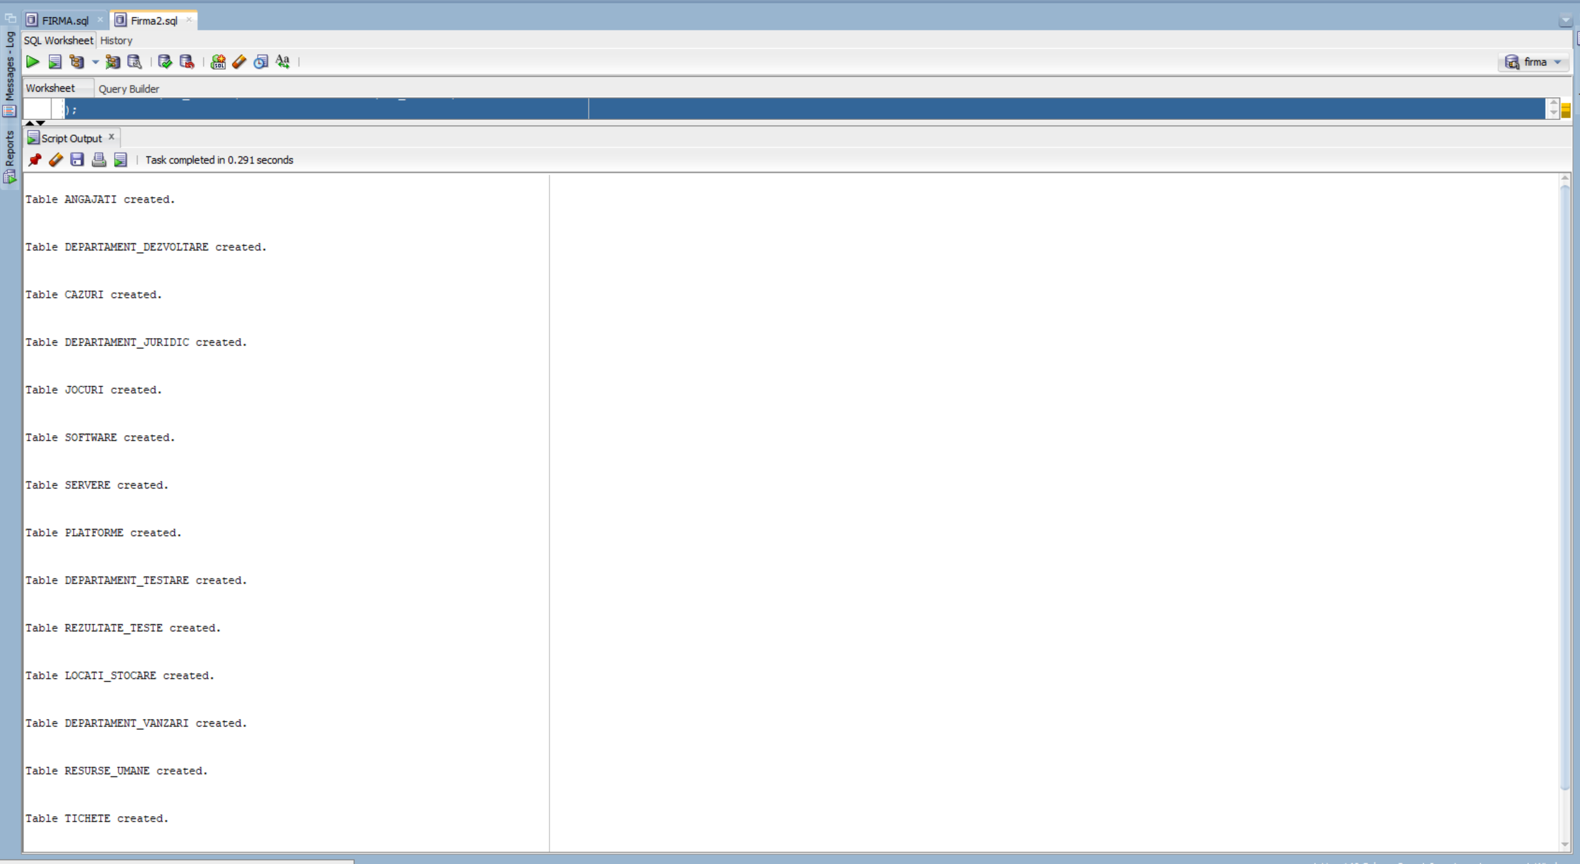

# 5. Adaugati informatii coerente in tabelele create (minim 5 inregistrari pentru fiecare entitate independenta; minim 10 inregistrari pentru tabela asociativa).

create sequence salary

start with 10000

increment by 200

MINvalue 1

maxvalue 100000

nocycle;

create sequence cod

start with 1

increment by 1

MINvalue 1

maxvalue 100

nocycle;

insert into angajati values (0,'SUMURDUC','ALEXANDRU','sumurduc2003@gmail.com' , '23-JUL-1981','23-MAY-1999',0773320197,null,100000);

insert into angajati(cod_angajat , nume ,prenume , data_angajare ,cod_manager) values (cod.nextval,'ESAR','MIHAI','10-JUL-2003',25);

insert into angajati(cod_angajat , nume ,prenume , data_angajare ,cod_manager) values (cod.nextval,'MILAN','ANDREI','02-JUN-2013',25);

insert into angajati(cod_angajat , nume ,prenume , data_angajare ,cod_manager) values (cod.nextval,'CICAR','GIGEL','03-MAY-2003',25);

insert into angajati(cod_angajat , nume ,prenume , data_angajare ,cod_manager) values (cod.nextval,'MAJOR','MITICA','20-MAR-2000',25);

insert into angajati(cod_angajat , nume ,prenume , data_angajare ,cod_manager) values (cod.nextval,'TRIM','LAZAR','23-JAN-2001',25);

insert into angajati(cod_angajat , nume ,prenume , data_angajare ,cod_manager) values (cod.nextval,'DIG','PIT','23-SEP-2003',25);

insert into angajati(cod_angajat , nume ,prenume , data_angajare ,cod_manager) values (cod.nextval,'PORET','GASU','23-OCT-2003',25);

insert into angajati(cod_angajat , nume ,prenume , data_angajare ,cod_manager) values (cod.nextval,'CASU','CASHU','23-NOV-2003',25);

insert into angajati(cod_angajat , nume ,prenume , data_angajare ,cod_manager) values (cod.nextval,'SAVAR','LARY','23-DEC-2003',25);

insert into angajati(cod_angajat , nume ,prenume , data_angajare ,cod_manager) values (cod.nextval,'SALBA','MITICA','14-MAR-2014',25);

insert into angajati(cod_angajat , nume ,prenume , data_angajare ,cod_manager) values (cod.nextval,'FAR','MIHAI','7-DEC-2007',25);

insert into angajati(cod_angajat , nume ,prenume , data_angajare ,cod_manager) values (cod.nextval,'ELAN','STEFAN','15-JAN-2007',25);

insert into angajati(cod_angajat , nume ,prenume , data_angajare ,cod_manager) values (cod.nextval,'JARD','DARIUS','12-FEB-2008',25);

insert into angajati(cod_angajat , nume ,prenume , data_angajare ,cod_manager) values (cod.nextval,'CORSO','ALEXANDRU','01-APR-2008',25);

insert into angajati(cod_angajat , nume ,prenume , data_angajare ,cod_manager) values (cod.nextval,'OLOF','SEBI','23-MAY-2009',25);

insert into angajati(cod_angajat , nume ,prenume , data_angajare ,cod_manager) values (cod.nextval,'ANDRO','LAURENTIU','23-JUN-2007',25);

insert into angajati(cod_angajat , nume ,prenume , data_angajare ,cod_manager) values (cod.nextval,'MITRA','NICHITA','20-JUL-2011',25);

insert into angajati(cod_angajat , nume ,prenume , data_angajare ,cod_manager) values (cod.nextval,'PRADAR','TALU','03-SEP-2012',25);

insert into angajati(cod_angajat , nume ,prenume , data_angajare ,cod_manager) values (cod.nextval,'SAHAR','KING','03-OCT-2013',25);

insert into angajati(cod_angajat , nume ,prenume , data_angajare ,cod_manager) values (cod.nextval,'SAMAU','COSMIN','11-NOV-2011',25);

insert into angajati(cod_angajat , nume ,prenume , data_angajare ,cod_manager) values (cod.nextval,'CARE','VICTOR','12-DEC-2012',25);

insert into angajati(cod_angajat , nume ,prenume , data_angajare ,cod_manager) values (cod.nextval,'SOLE','COSICI','22-JUL-2003',25);

insert into angajati(cod_angajat , nume ,prenume , data_angajare ,cod_manager) values (cod.nextval,'SAINT','CANIC','23-JUN-2012',25);

insert into angajati(cod_angajat , nume ,prenume , data_angajare ,cod_manager) values (cod.nextval,'SINT','SILIAN','23-JUN-2003',25);

insert into angajati(cod_angajat , nume ,prenume , data_angajare ,cod_manager) values (cod.nextval,'NICHITA','PITICA','23-MAR-2003',0);

insert into angajati values (cod.nextval ,'LAZAR','ANDREI','2003@gmail.com','23-MAY-1987','23-MAY-2009',31312312312 , 29,salary.nextval);

insert into angajati values (cod.nextval ,'SAMANTEAN','MARIUS','cazur@gmail.com','12-MAY-1987','23-JUN-2003',31231231231 ,29 ,salary.nextval);

insert into angajati values (cod.nextval ,'PAR','COSTEL','stefi@gmail.com','04-JUN-1977','01-APR-2008', 32321314,29 ,salary.nextval);

insert into angajati values (cod.nextval ,'FALU','LUCIAN','tare@gmail.com','03-JUL-1981','23-SEP-2003',513123123 ,0,salary.nextval);

insert into angajati values (cod.nextval ,'ZAHAR','C`OMINA','galati@gmail.com','30-NOV-1980','23-JUN-2003', 4124124,29 ,salary.nextval);

insert into angajati values (cod.nextval ,'CEZART','ANDREA','stardust@gmail.com','01-DEC-1977','23-SEP-2003',14124124 ,29 ,salary.nextval);

insert into angajati values (cod.nextval ,'ANDREI','ANDREI','lorean@gmail.com','17-OCT-1982','23-JUN-2003', 2412412,29 ,salary.nextval);

insert into angajati values (cod.nextval ,'LUCEAF','STEFAN','lordofthecode@gmail.com','15-MAR-1967','23-SEP-2003',1414214 ,29 ,salary.nextval);

insert into angajati values (cod.nextval ,'CARAI','PAUL','thelastcoder@gmail.com','22-APR-1977','23-SEP-2003',41241241 ,29 ,salary.nextval);

insert into angajati values (cod.nextval ,'GHERG','LUCA','nimer@gmail.com','02-MAY-1984','23-SEP-2003',4141414 ,29 ,salary.nextval);

insert into angajati values (cod.nextval ,'CEZART','ANDREI','2002@gmail.com','24-MAY-1987','23-MAY-2007',51312312312 , 0,salary.nextval);

insert into angajati values (cod.nextval ,'FALU','PAUL','ctur@gmail.com','13-MAY-1987','22-JUl-2003',31221231231 ,37 ,salary.nextval);

insert into angajati values (cod.nextval ,'NICHITAAR','COSTEL','stoii@gmail.com','05-JUN-1977','02-APR-2009', 12321314,37 ,salary.nextval);

insert into angajati values (cod.nextval ,'FALU','SOLE','tarus@gmail.com','07-JUL-1981','20-SEP-2004',513123423 ,0,salary.nextval);

insert into angajati values (cod.nextval ,'ZAHAR','C`OMINA','galati_braila@gmail.com','22-NOV-1981','23-JUN-2003', 4324124,37 ,salary.nextval);

insert into angajati values (cod.nextval ,'CEZART','ANDREA','star@gmail.com','05-DEC-1977','23-OCT-2003',142124124 ,37 ,salary.nextval);

insert into angajati values (cod.nextval ,'CARAI','STEFAN','loreanNus@gmail.com','18-OCT-1982','23-MAR-2003', 2414412,37 ,salary.nextval);

insert into angajati values (cod.nextval ,'PITICA','STEFAN','stefan@gmail.com','19-MAR-1967','23-SEP-2003',1514214 ,37 ,salary.nextval);

insert into angajati values (cod.nextval ,'CARAI','PAUL','coderoftheabyys@gmail.com','23-APR-1977','23-SEP-2003',412241 ,37 ,salary.nextval);

insert into angajati values (cod.nextval ,'SAMAU','VICTOR','miner@gmail.com','04-MAY-1984','23-SEP-2003',5141414 ,37 ,salary.nextval);

insert into angajati values (cod.nextval,'LAZARUT','MATEI','1@gmail.com','21-AUG-1992','23-SEP-2003',31231 ,0,salary.nextval );

insert into angajati values (cod.nextval,'ZAHAR','OLAF','2@gmail.com','22-NOV-1982','23-SEP-2003', 31231,47,salary.nextval );

insert into angajati values (cod.nextval,'CRIT','QUATAR','3@gmail.com','24-SEP-1982','23-SEP-2003',313131 ,47,salary.nextval );

insert into angajati values (cod.nextval,'EDGE','CALAR','4@gmail.com','15-NOV-1972','23-SEP-2003',2313123 ,47,salary.nextval );

insert into angajati values (cod.nextval,'CLIFF','CARAT','5@gmail.com','16-OCT-1992','23-SEP-2003', 312312,47,salary.nextval );

insert into angajati values (cod.nextval,'HIMILTON','ZACAR','6@gmail.com','03-JUN-1979','23-SEP-2003', 13123,47,salary.nextval );

insert into angajati values (cod.nextval,'WINTER','ZATAR','7@gmail.com','02-JUL-1982','23-SEP-2003',312312 ,47,salary.nextval );

insert into angajati values (cod.nextval,'CARCAS','ROAMAN','8@gmail.com','20-MAR-1977','23-SEP-2003',3131 ,47,salary.nextval );

insert into angajati values (cod.nextval,'MARIT','MATEI','9@gmail.com','11-MAR-1983','23-SEP-2003', 312312,47,salary.nextval );

insert into angajati values (cod.nextval,'SALAR','GETA','11@gmail.com','12-SEP-1987','23-SEP-2003', 3131,47,salary.nextval );

insert into angajati values (cod.nextval,'CAZAR','GHEORGHE','12@gmail.com','19-NOV-1992','23-SEP-2003',31311 ,47,salary.nextval );

insert into angajati values (cod.nextval,'TRAZAT','DANA','13@gmail.com','27-OCT-1952','23-SEP-2003', 3131,47,salary.nextval );

insert into angajati values (cod.nextval,'FARAR','COSTIN','14@gmail.com','28-MAR-1992','23-SEP-2003',3131 ,47,salary.nextval );

insert into angajati values (cod.nextval,'TRAMAR','IULIA','15@gmail.com','30-JUL-1952','23-SEP-2003', 31313,47,salary.nextval );

insert into angajati values (cod.nextval,'CAZAT','ANDREI','16@gmail.com','01-SEP-1972','23-SEP-2003', 31313,47,salary.nextval );

insert into angajati values (cod.nextval,'COST','MATEI','matei1@gmail.com','25-DEC-1990','23-SEP-2003',31231 ,0,salary.nextval );

insert into angajati values (cod.nextval,'TRAHAR','STEFAN','trhar123@gmail.com','27-AUG-1991','23-SEP-2003',31231 ,62,salary.nextval );

insert into angajati values (cod.nextval,'MATRUS','MARIA','mary@gmail.com','08-JUN-1992','23-SEP-2003',31231 ,62,salary.nextval );

insert into angajati values (cod.nextval,'DLOOD','MARTI','maart1@gmail.com','11-JUL-1992','23-SEP-2003',31231 ,62,salary.nextval );

insert into angajati values (cod.nextval,'VERTA','STEFANIA','stefV@gmail.com','21-SEP-1989','23-SEP-2003',31231 ,62,salary.nextval );

insert into angajati values (cod.nextval,'CAZUR','ALEXANDRA','alexi@gmail.com','20-MAY-1988','23-SEP-2003',31231 ,62,salary.nextval );

insert into angajati values (cod.nextval,'TRANT','MAYTREI','maytr1@gmail.com','09-MAR-1987','23-SEP-2003',31231 ,62,salary.nextval );

insert into angajati values (cod.nextval,'LAZARUT','STEFANIA','lazarPit@gmail.com','01-SEP-1986','23-SEP-2003',31231 ,62,salary.nextval );

insert into angajati values (cod.nextval,'CORN','ALEXANDRU','corn@gmail.com','1-JUL-1985','23-SEP-2003',31231 ,62,salary.nextval );

insert into angajati values (cod.nextval,'ZORO','DOREL','ZORO@gmail.com','21-AUG-1990','23-SEP-2003',31231 ,62,salary.nextval );

insert into platforme values (10,'www.steam.us',sysdate);

insert into platforme values (9,'www.amazon.org',sysdate);

insert into platforme values (8,'www.shops.ru',sysdate);

insert into platforme values (7,'www.cracked.ro','11-MAR-1999');

insert into platforme values (6,'www.safari.rt','17-JUL-2000');

insert into platforme values (5,'www.zajar.jp','21-JAN-1999');

insert into platforme values (4,'www.grass.mp','22-APR-2002');

insert into platforme values (3,'www.games.ds',sysdate);

insert into platforme values (2,'www.jocurifun.ro','23-MAR-2002');

insert into platforme values (1,'www.mathgames.rr',sysdate);

insert into locati_stocare values(1,20,'BUCURESTI','ROMANIA','SECTORUL 3','IDEPEDENTEI 1');

insert into locati_stocare values(2,19,'NEY YORK','USA',NULL,'Park Avenue');

insert into locati_stocare values(3,18,'NEW YORK','USA',NULL,'Canal Street');

insert into locati_stocare values(4,22,'LONDON','UK',NULL,'Fleet Street');

insert into locati_stocare values(5,23,'PARIS','FRANCE',NULL,'Rue de Rivoli');

insert into locati_stocare values(6,4,'PARIS','FRANCE',NULL,'Avenue de la République');

insert into locati_stocare values(7,11,'LONDON','UK',NULL,'Oxford Street');

insert into locati_stocare values(8,19,'TIMISOARA','ROMANIA','TIMISOARA','UNIRI');

insert into locati_stocare values(9,21,'BUCURESTI','ROMANIA','SECTORUL 2','LEONIDA 2');

insert into locati_stocare values(10,20,'Galati','ROMAANIA','GALATI','GHEORGHE DOJA 1');

insert into departament_vanzari values( 1, 1, 2,'vanzari_maxime',25 );

insert into departament_vanzari values( 2, 1, 1,'crestere_opinie',25 );

insert into departament_vanzari values( 3, 2, 2,'crestere_opinie', 25);

insert into departament_vanzari values( 4, 3, 2,'vanzari_maxime',25 );

insert into departament_vanzari values( 5, 3, 5,'crestere_opinie',25 );

insert into departament_vanzari values( 6, 1, 3,'crestere_opinie',25 );

insert into departament_vanzari values( 7, 4, 6,'crestere_opinie',25 );

insert into departament_vanzari values( 8, 7, 4,'dezvoltare_piata',25 );

insert into departament_vanzari values( 9, 5, 1,'dezvoltare_piata', 25);

insert into departament_vanzari values( 10, 10,5 ,'dezvoltare_piata',25 );

insert into departament_vanzari values( 11, 6, 8,'dezvoltare_piata', 25);

insert into departament_vanzari values( 12, 6, 6,'vanzari_maxime',25 );

insert into departament_vanzari values( 13, 7, 1,'crestere_opinie', 25);

insert into departament_vanzari values( 14, 1, 7,'crestere_opinie', 25);

insert into departament_vanzari values( 15, 8, 2,'crestere_opinie', 25);

insert into departament_vanzari values( 16, 3, 8,'vanzari_maxime',25 );

insert into departament_vanzari values( 17, 9, 5,'dezvoltare_piata', 25);

insert into departament_vanzari values( 18, 2, 9,'vanzari_maxime',25 );

insert into departament_vanzari values( 19, 10,4 ,'vanzari_maxime', 25);

insert into departament_vanzari values( 20, 1, 10,'vanzari_maxime', 25);

insert into departament_vanzari values( 21, 10,1 ,'crestere_opinie', 25);

insert into departament_vanzari values( 22, 2,5 ,'crestere_opinie', 25);

insert into departament_vanzari values( 23, 3,7 ,'crestere_opinie', 25);

insert into departament_vanzari values( 24, 4,8 ,'crestere_opinie', 25);

insert into departament_vanzari values( 25, 5,8 ,'crestere_opinie', 25);

insert into cazuri values(10,'copyright1','inceput');

insert into cazuri values(9,'violenta_injoc1','inceput');

insert into cazuri values(8,'copyright2','termint');

insert into cazuri values(7,'violenta_injoc4','termint');

insert into cazuri values(6,'copyright3','termint');

insert into cazuri values(5,'copyright4','inceput');

insert into cazuri values(4,'violenta_injoc2','termint');

insert into cazuri values(3,'violenta_injoc3','neinceput');

insert into cazuri values(2,'copyright5','neinceput');

insert into cazuri values(1,'copyright6','neinceput');

insert into departament_juridic values( 46, 1, 47);

insert into departament_juridic values( 47, 2, 47);

insert into departament_juridic values( 48, 3, 47);

insert into departament_juridic values( 49, 4, 47);

insert into departament_juridic values( 50, 5, 47);

insert into departament_juridic values( 51, 6, 47);

insert into departament_juridic values( 52, 7, 47);

insert into departament_juridic values( 53, 8, 47);

insert into departament_juridic values( 54, 9, 47);

insert into departament_juridic values( 55, 3, 47);

insert into departament_juridic values( 56, 4, 47);

insert into departament_juridic values( 57, 5, 47);

insert into departament_juridic values( 58, 7, 47);

insert into departament_juridic values( 59, 3, 47);

insert into departament_juridic values( 60, 9, 47);

insert into resurse_umane values(61,24,62);

insert into resurse_umane values(62,22,62);

insert into resurse_umane values(63,18,62);

insert into resurse_umane values(64,17,62);

insert into resurse_umane values(65,14,62);

insert into resurse_umane values(66,9,62);

insert into resurse_umane values(67,20,62);

insert into resurse_umane values(68,7,62);

insert into resurse_umane values(69,12,62);

insert into resurse_umane values(70,10,62);

insert into tichete values(19,61 , 'neinceput','probleme_graphica');

insert into tichete values(18, 62, 'abordat','probleme_graphica');

insert into tichete values(17, 63, 'abordat','blue_screen');

insert into tichete values(16, 64, 'abordat','probleme_graphica');

insert into tichete values(15, 61, 'rezolvat','blue_screen');

insert into tichete values(13, 63, 'neinceput','blue_screen');

insert into tichete values(14, 65, 'abordat','probleme_graphica');

insert into tichete values(12, 66, 'abordat','blue_screen');

insert into tichete values(11, 67, 'neinceput','probleme_graphica');

insert into tichete values(10, 70, 'abandonat','blue_screen');

insert into software values(6,'UNITY','game_software');

insert into software values(5,'AAA','game_software');

insert into software values(4,'DESIM','design');

insert into software values(3,'CREATE','modelare_3d');

insert into software values(2,'GRAH','graphica');

insert into software values(1,'STORLINE','story');

insert into software values(7,'AI','non player characters');

insert into software values(8,'MPA','map power acents');

insert into software values(9,'CREATE','AUTOMIZATION');

insert into software values(10,'DEVELOPE','developer console');

insert into jocuri (cod_joc , NUME ) values(10,'WORLD_OF_TANKS');

insert into jocuri (cod_joc , NUME ) values(9,'WORLD_OF_MAGIC');

insert into jocuri (cod_joc , NUME ) values(8,'SAMURAI_BACK');

insert into jocuri (cod_joc , NUME ) values(7,'RETURN');

insert into jocuri (cod_joc , NUME ) values(6,'FIVE_WEEKS');

insert into jocuri (cod_joc , NUME ) values(5,'NOCH');

insert into jocuri (cod_joc , NUME ) values(4,'HE');

insert into jocuri (cod_joc , NUME ) values(3,'SHE');

insert into jocuri (cod_joc , NUME ) values(2,'THEY');

insert into jocuri (cod_joc , NUME ) values(1,'ORIGINS');

insert into servere values(1,'EUROPA',100000,1);

insert into servere values(2,'EUROPA',100000,2);

insert into servere values(3,'EUROPA',100000,3);

insert into servere values(4,'EUROPA',100000,4);

insert into servere values(5,'EUROPA',100000,5);

insert into servere values(6,'EUROPA',100000,6);

insert into servere values(7,'EUROPA',100000,7);

insert into servere values(9,'EUROPA',100000,8);

insert into servere values(10,'EUROPA',100000,10);

insert into servere values(11,'ASIA',100000,1);

insert into servere values(12,'ASIA',100000,2);

insert into servere values(13,'ASIA',100000,3);

insert into servere values(14,'ASIA',100000,4);

insert into servere values(15,'ASIA',100000,5);

insert into servere values(16,'ASIA',100000,6);

insert into servere values(17,'AMERICA',100000,7);

insert into servere values(18,'AMERICA',100000,8);

insert into servere values(19,'AMERICA',100000,9);

insert into servere values(20,'AMERICA',100000,10);

insert into departament_dezvoltare values (26,29);

insert into departament_dezvoltare values (27,29);

insert into departament_dezvoltare values (28,29);

insert into departament_dezvoltare values (29,29);

insert into departament_dezvoltare values (30,29);

insert into departament_dezvoltare values (31,29);

insert into departament_dezvoltare values (32,29);

insert into departament_dezvoltare values (33,29);

insert into departament_dezvoltare values (34,29);

insert into departament_dezvoltare values (35,29);

insert into dezvoltare values(26,1,1);

insert into dezvoltare values(27,2,2);

insert into dezvoltare values(26,3,1);

insert into dezvoltare values(30,4,3);

insert into dezvoltare values(29,5,5);

insert into dezvoltare values(31,1,4);

insert into dezvoltare values(28,2,6);

insert into dezvoltare values(32,3,1);

insert into dezvoltare values(33,6,2);

insert into dezvoltare values(35,7,4);

insert into dezvoltare values(34,8,5);

insert into departament_testare values(37,1,37);

insert into departament_testare values(38,2,37);

insert into departament_testare values(39,4,37);

insert into departament_testare values(40,3,37);

insert into departament_testare values(41,5,37);

insert into departament_testare values(42,6,37);

insert into departament_testare values(43,7,37);

insert into departament_testare values(44,8,37);

insert into departament_testare values(45,9,37);

insert into departament_testare values(46,10,37);

insert into rezultate_teste values(1, 1,37, sysdate, 7, 'greseli gramaatica + probleme de randare');

insert into rezultate_teste values(2,2,38,sysdate,8,'meniu neintuitiv');

insert into rezultate_teste values(3,3,39,sysdate,9,'meniu neintuitiv');

insert into rezultate_teste values(4,4,39,sysdate,10,'');

insert into rezultate_teste values(5,5,40,sysdate,10,'');

insert into rezultate_teste values(6,1,41,sysdate,6,'eori + crashuri');

insert into rezultate_teste values(7,2,42,sysdate,9,'meniu neintuitiv');

insert into rezultate_teste values(8,4,43,sysdate,1,'literalmente a sters os');

insert into rezultate_teste values(9,5,44,sysdate,3,'greseli gramaatica + probleme de randare');

insert into rezultate_teste values(10,6,45,sysdate,6,' nu se salveasa progresul');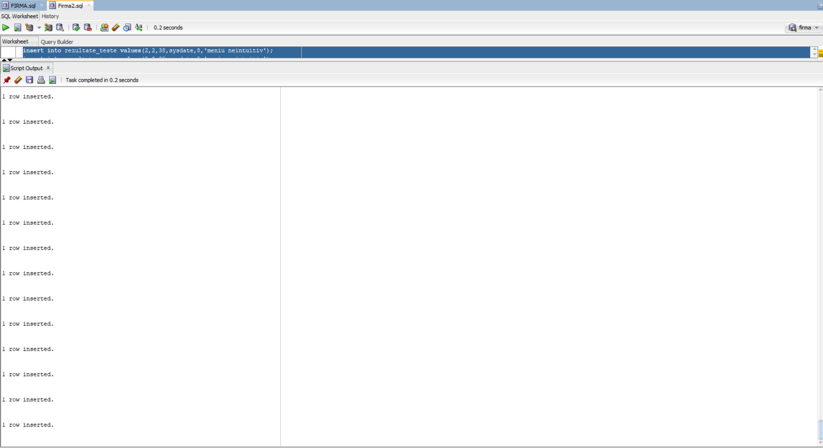

# 6. Formulati in limbaj natural o problema pe care sa o rezolvati folosind un subprogram stocat independent care sa utilizeze toate cele 3 tipuri de colectii studiate. Apelati subprogramul.

-- Pentru un joc dat (id), afiseaza si salveaza serverele pe care le are, testele care au fost facute pe ele si software-urile cu care a fost creat.

CREATE OR REPLACE PROCEDURE afisare (id_joc JOCURI.COD_JOC%TYPE) AS

TYPE ServereIndexate IS TABLE OF SERVERE%ROWTYPE INDEX BY PLS_INTEGER;

v_servere_indexate ServereIndexate;

TYPE TesteImbatabile IS TABLE OF REZULTATE_TESTE%ROWTYPE INDEX BY PLS_INTEGER;

v_teste_imbatabile TesteImbatabile;

TYPE SoftwareVector IS VARRAY(100) OF DEZVOLTARE.COD_SOFTWARE%TYPE;

v_software_vector SoftwareVector := SoftwareVector();

contor NUMBER := 1;

nume software.nume%type;

BEGIN

select nume into nume from jocuri where cod_joc = id_joc;

DBMS_OUTPUT.PUT_LINE('Jocul este: ' || '' || nume);

FOR server_rec IN (SELECT * FROM SERVERE WHERE COD_JOC = id_joc) LOOP

v_servere_indexate(contor) := server_rec;

contor := contor + 1;

END LOOP;

contor := 1;

FOR teste_rec IN (SELECT * FROM REZULTATE_TESTE WHERE COD_JOC = id_joc) LOOP

v_teste_imbatabile(contor) := teste_rec;

contor := contor + 1;

END LOOP;

contor := 1;

FOR software_rec IN (SELECT DISTINCT COD_SOFTWARE FROM DEZVOLTARE WHERE COD_JOC = id_joc) LOOP

v_software_vector.EXTEND;

v_software_vector(contor) := software_rec.COD_SOFTWARE;

contor := contor + 1;

END LOOP;

DBMS_OUTPUT.PUT_LINE('Servere in tabel indexat: ');

FOR i IN 1..v_servere_indexate.COUNT LOOP

DBMS_OUTPUT.PUT_LINE(v_servere_indexate(i).COD_SERVER || ' - ' || v_servere_indexate(i).REGIUNE || ' - ' || v_servere_indexate(i).CAPACITATE_MAXIMA);

END LOOP;

DBMS_OUTPUT.PUT_LINE('Teste in tabel indexat:');

FOR i IN 1..v_teste_imbatabile.COUNT LOOP

DBMS_OUTPUT.PUT_LINE(v_teste_imbatabile(i).COD_TEST || ' - ' || v_teste_imbatabile(i).NOTA_TEST);

END LOOP;

DBMS_OUTPUT.PUT_LINE('Software in vector:' );

FOR i IN 1..v_software_vector.COUNT LOOP

select nume into nume from software where cod_software = v_software_vector(i);

DBMS_OUTPUT.PUT_LINE(v_software_vector(i) || ' - ' || nume);

END LOOP;

END;

/

EXEC afisare(1);

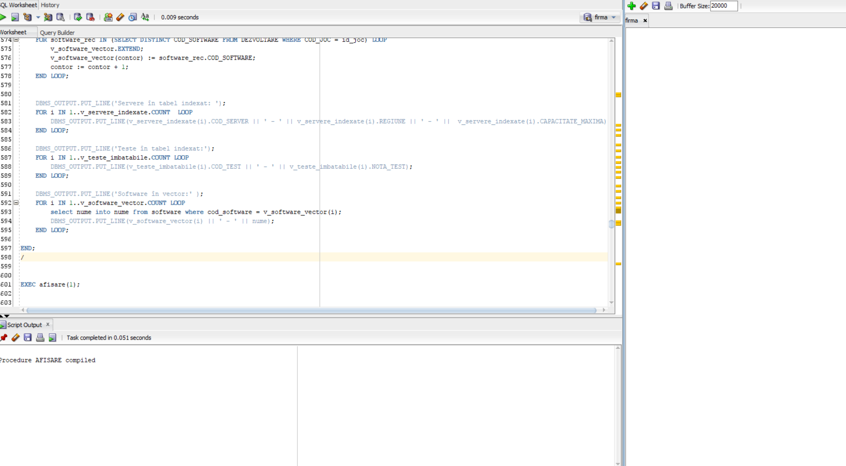

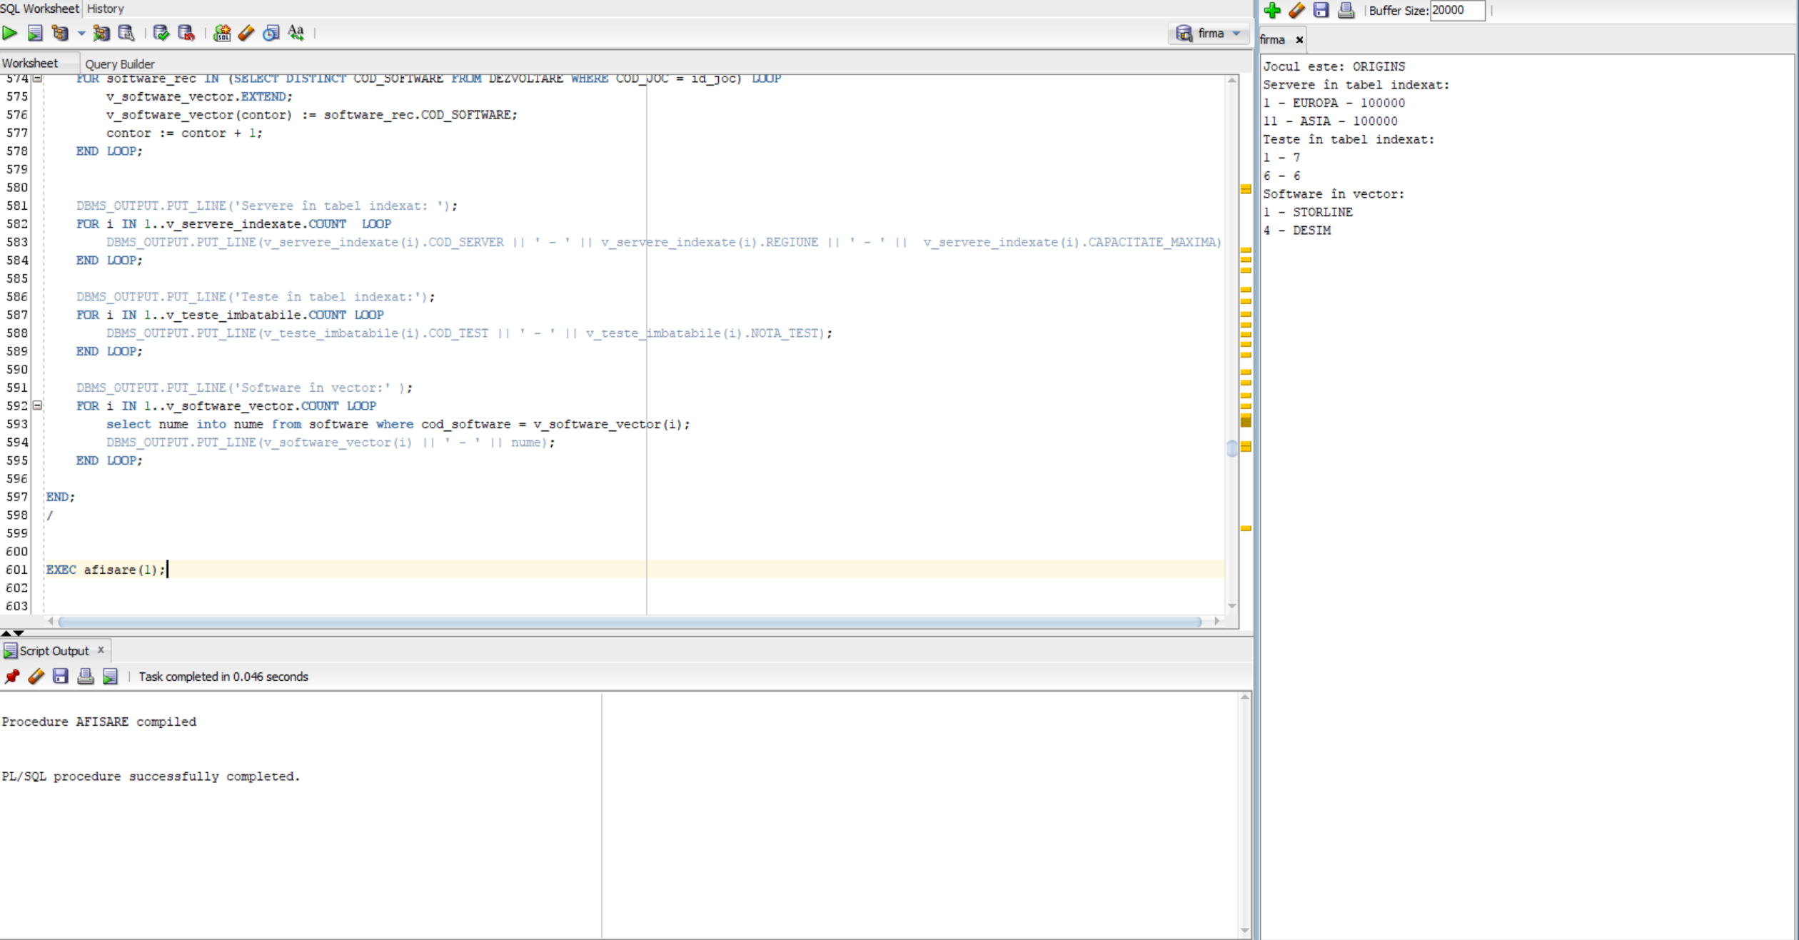

# 7. Formulati in limbaj natural o problema pe care sa o rezolvati folosind un subprogram stocat independent care sa utilizeze 2 tipuri diferite de cursoare studiate, unul dintre acestea fiind cursor parametrizat, dependent de celalalt cursor. Apelati subprogramul.

Primind codul unui joc, afisati toti angajatii care au lucrat la acest cod si software-ul pe care l-au folosit.

CREATE OR REPLACE PROCEDURE GestionareEchipeDezvoltare (COD_JOC_IN IN JOCURI.COD_JOC%TYPE) AS

CURSOR CurAngajati IS

SELECT A.COD_ANGAJAT, A.NUME, A.PRENUME, D.COD_JOC, D.COD_SOFTWARE

FROM ANGAJATI A

JOIN DEZVOLTARE D ON A.COD_ANGAJAT = D.COD_ANGAJAT

WHERE D.COD_JOC = COD_JOC_IN;

CURSOR CurSoftware (COD_SOFTWARE_IN IN SOFTWARE.COD_SOFTWARE%TYPE) IS

SELECT NUME, UTILIZARE

FROM SOFTWARE

WHERE COD_SOFTWARE = COD_SOFTWARE_IN;

nume_ANGAJAT ANGAJATI.NUME%TYPE;

prenume_ANGAJAT ANGAJATI.PRENUME%TYPE;

nume_SOFTWARE SOFTWARE.NUME%TYPE;

V_UTILIZARE_SOFTWARE SOFTWARE.UTILIZARE%TYPE;

BEGIN

FOR RecAngajat IN CurAngajati LOOP

nume_ANGAJAT := RecAngajat.NUME;

prenume_ANGAJAT := RecAngajat.PRENUME;

FOR RecSoftware IN CurSoftware(RecAngajat.COD_SOFTWARE) LOOP

nume_SOFTWARE := RecSoftware.NUME;

V_UTILIZARE_SOFTWARE := RecSoftware.UTILIZARE;

DBMS_OUTPUT.PUT_LINE('Angajat: ' || nume_ANGAJAT || ' ' || prenume_ANGAJAT);

DBMS_OUTPUT.PUT_LINE('Software Utilizat: ' || nume_SOFTWARE || ' - ' || V_UTILIZARE_SOFTWARE);

DBMS_OUTPUT.PUT_LINE('---');

END LOOP;

END LOOP;

END GestionareEchipeDezvoltare;

/

EXEC GestionareEchipeDezvoltare(1);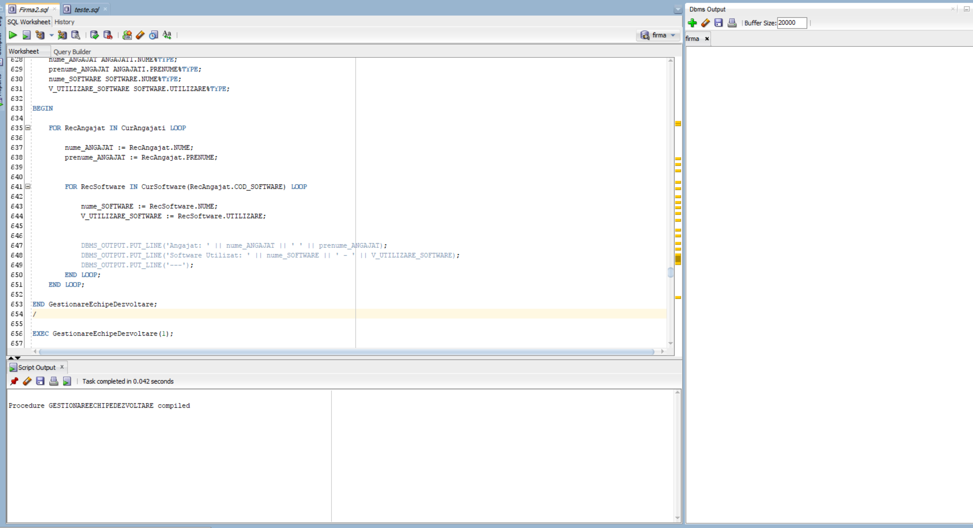

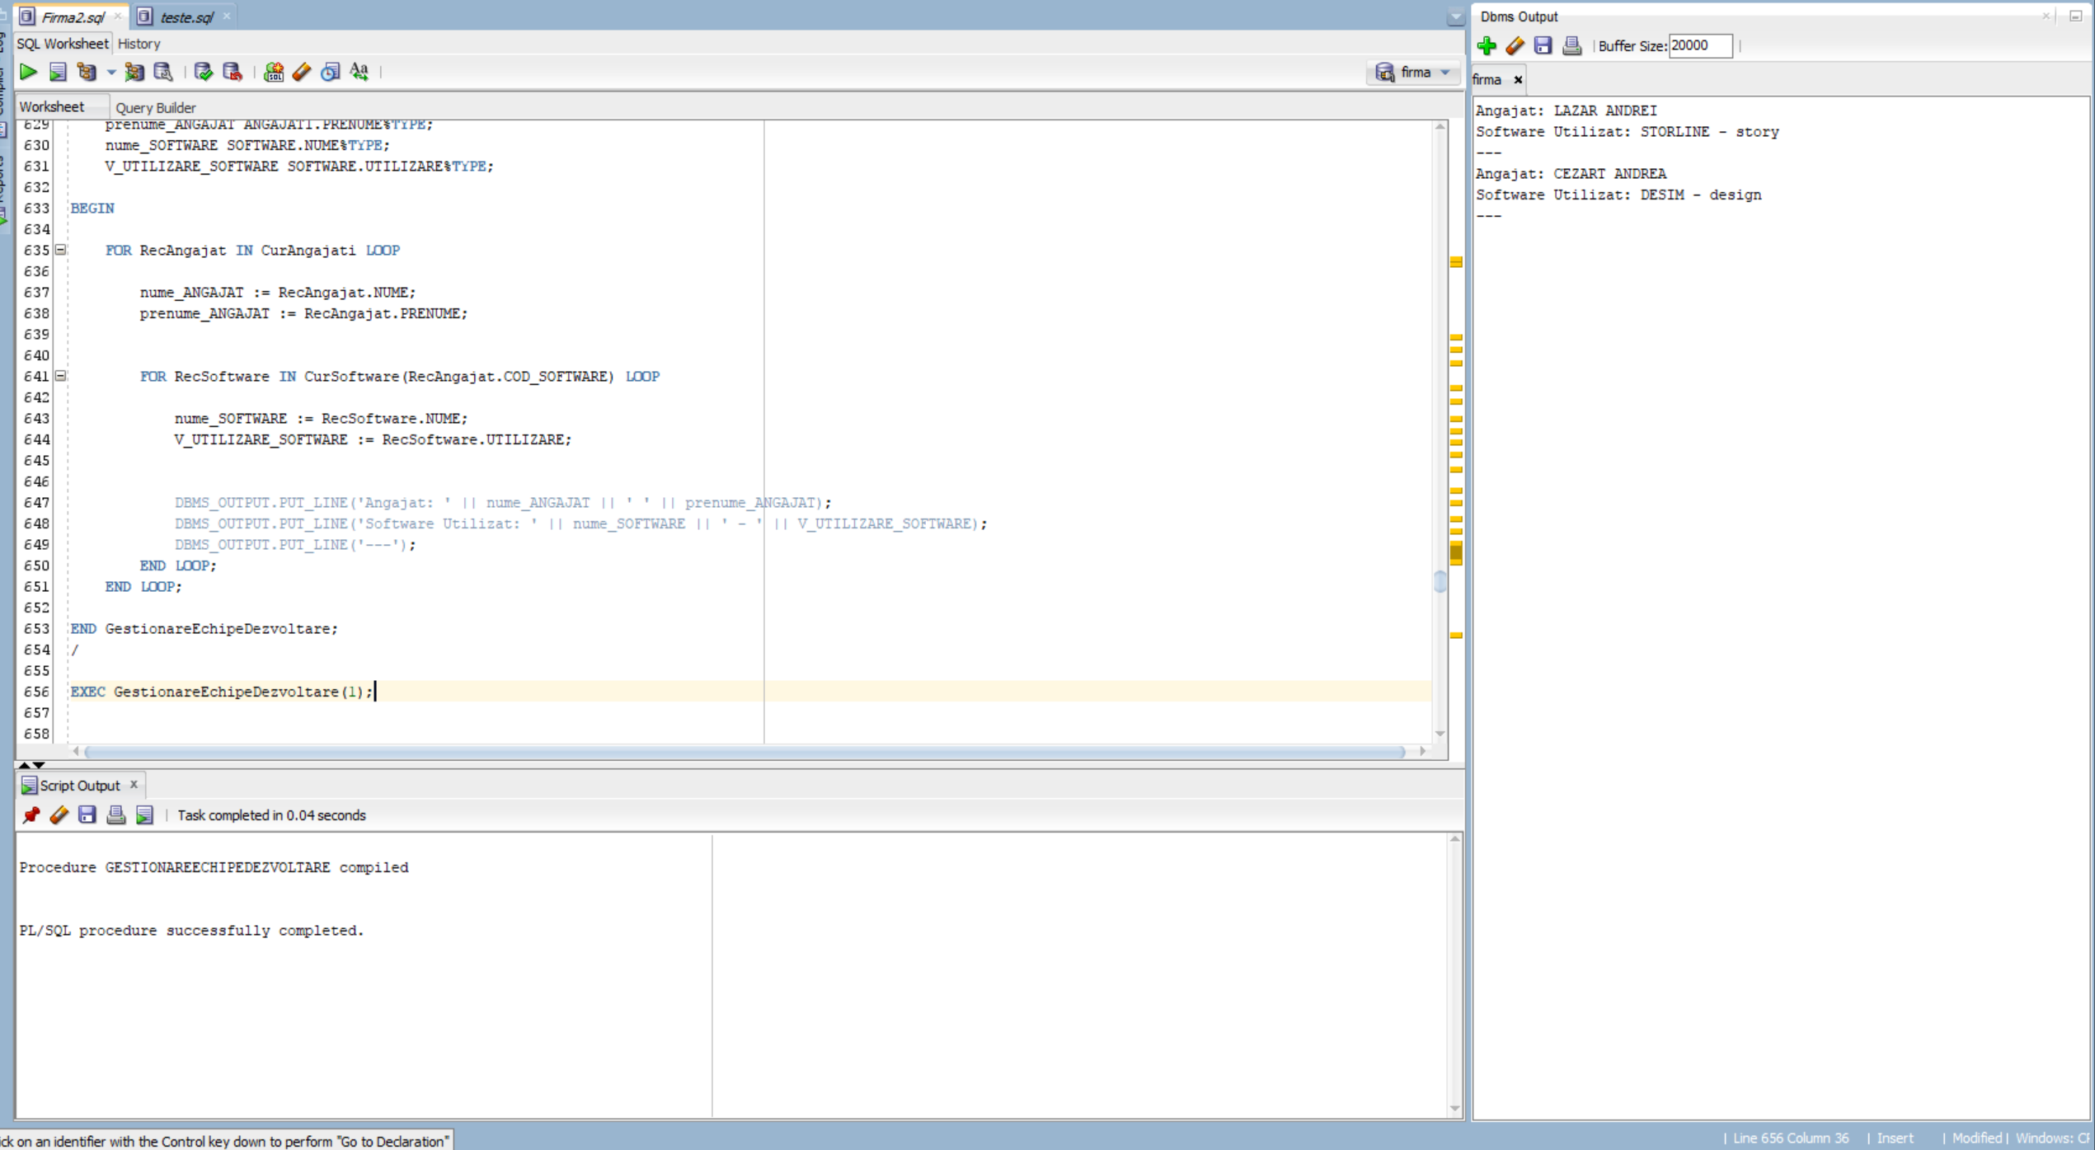

# 8. Formulati in limbaj natural o problema pe care sa o rezolvati folosind un subprogram stocat independent de tip functie care sa utilizeze intr-o singura comanda SQL 3 dintre tabelele definite. Definiti minim 2 exceptii proprii. Apelati subprogramul astfel incât sa evidentiati toate cazurile definite si tratate.

Afisati angajatul care a lucrat sau lucreaza cu software-ul (al carui nume este dat). In cazul in care nu exista un angajat care a lucrat sau lucreaza cu acel software sau daca exista mai multi angajati care lucreaza cu acel software, va rugam sa afisati o eroare.

CREATE OR REPLACE FUNCTION f1(

numes SOFTWARE.NUME%TYPE

) RETURN ANGAJATI.NUME%TYPE

IS

nume ANGAJATI.NUME%TYPE;

AngajatNotFound EXCEPTION;

PRAGMA EXCEPTION_INIT(AngajatNotFound, -20101);

SoftwareInUse EXCEPTION;

PRAGMA EXCEPTION_INIT(SoftwareInUse, -20102);

BEGIN

SELECT A.NUME

INTO nume

FROM ANGAJATI A

JOIN DEZVOLTARE D ON D.COD_ANGAJAT = A.COD_ANGAJAT

JOIN SOFTWARE S ON S.COD_SOFTWARE = D.COD_SOFTWARE

WHERE LOWER(S.NUME) = LOWER(numes);

RETURN nume;

EXCEPTION

WHEN NO_DATA_FOUND THEN

RAISE_APPLICATION_ERROR(-20101, 'Angajatul nu a fost gasit sau nu exista software cu numele acesta');

WHEN TOO_MANY_ROWS THEN

RAISE_APPLICATION_ERROR(-20102, 'Sunt mai multi angajati care folosesc acest software.');

END f1;

/

-- no data found

select f1('Minecraft') from dual;

--bun

select f1('Unity') from dual;

--TOO MANY ROWS

select f1('STORLINE') from dual;

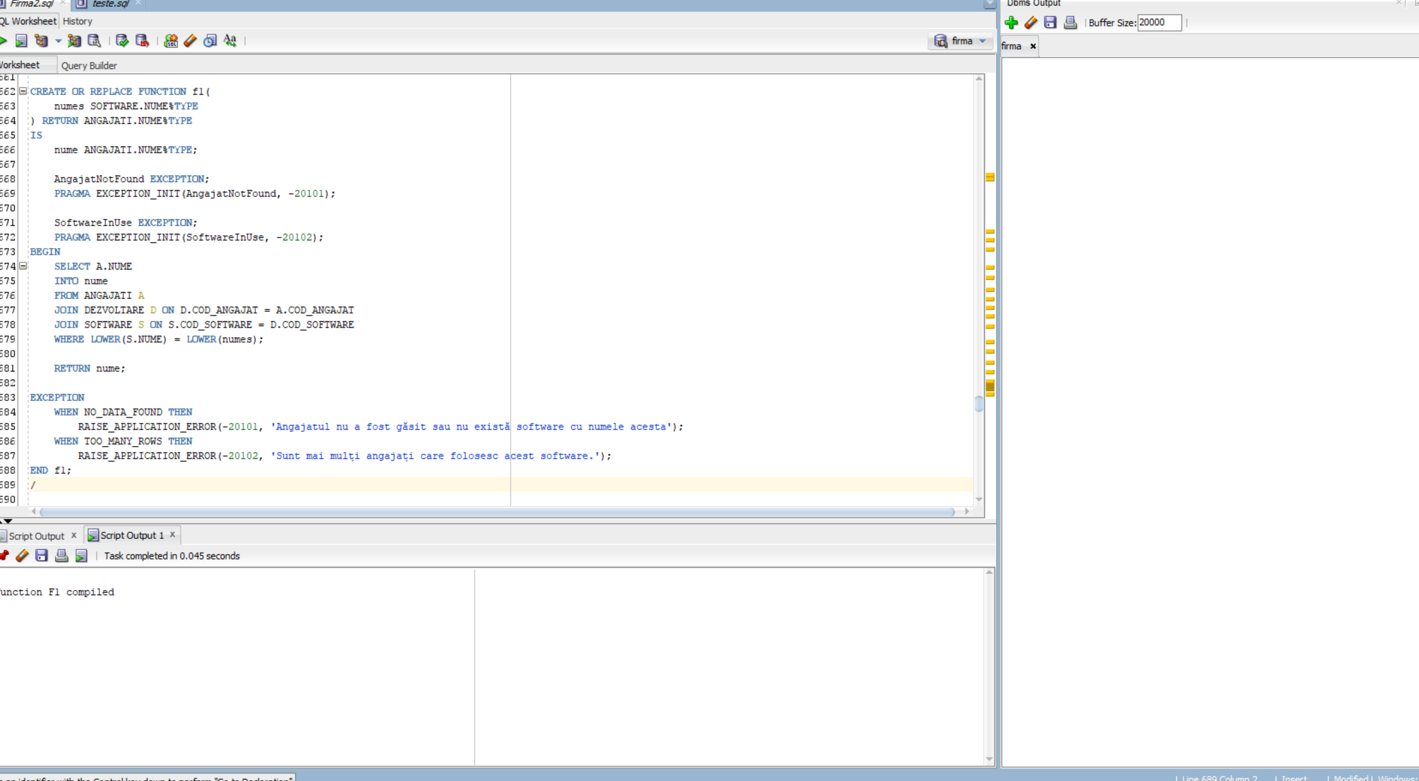

No data found.

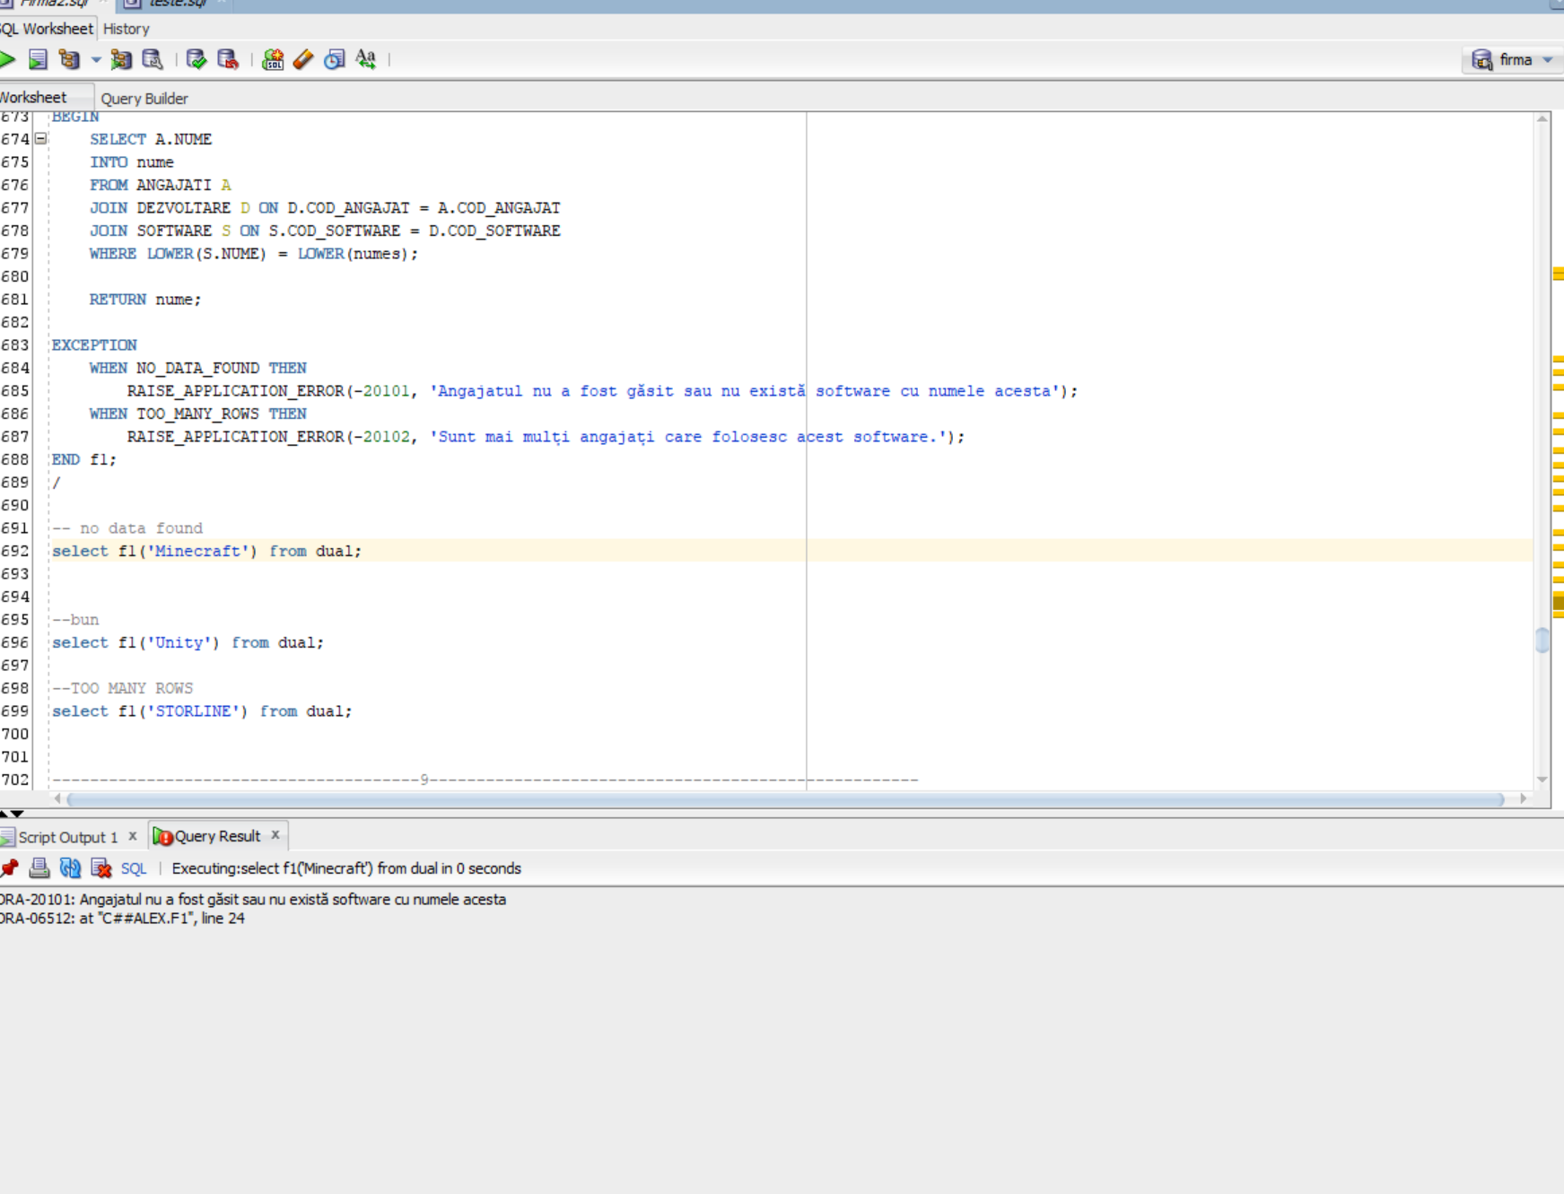

Cazul in care functioneaza fara nicio problema.

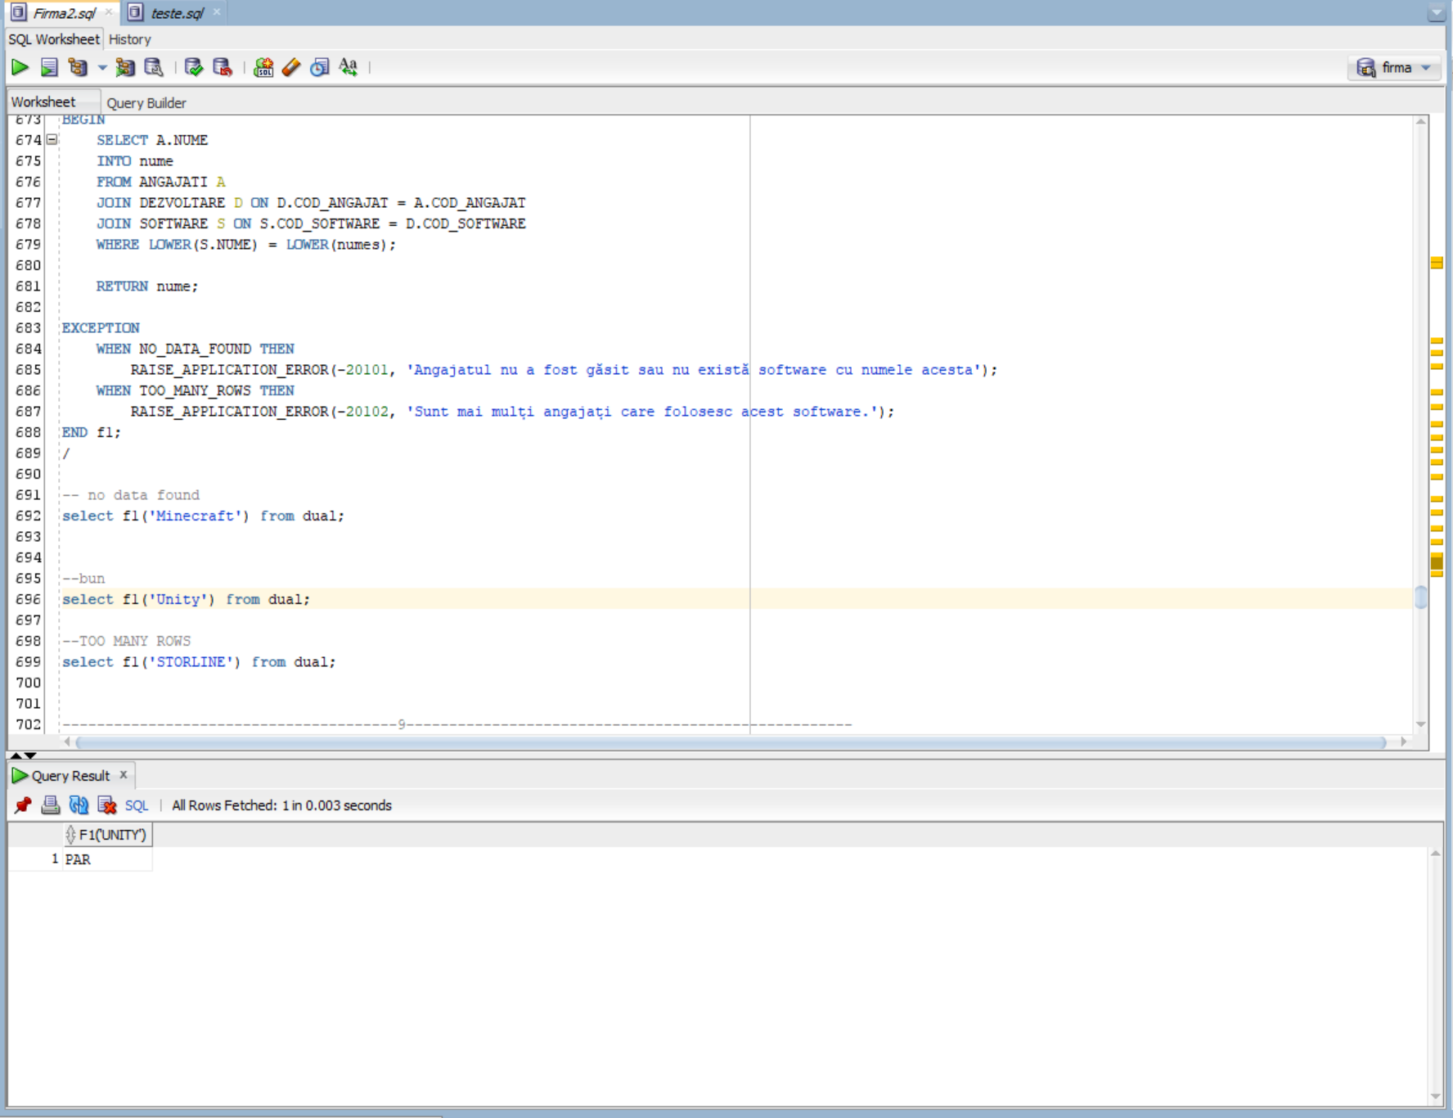

Too many rows.

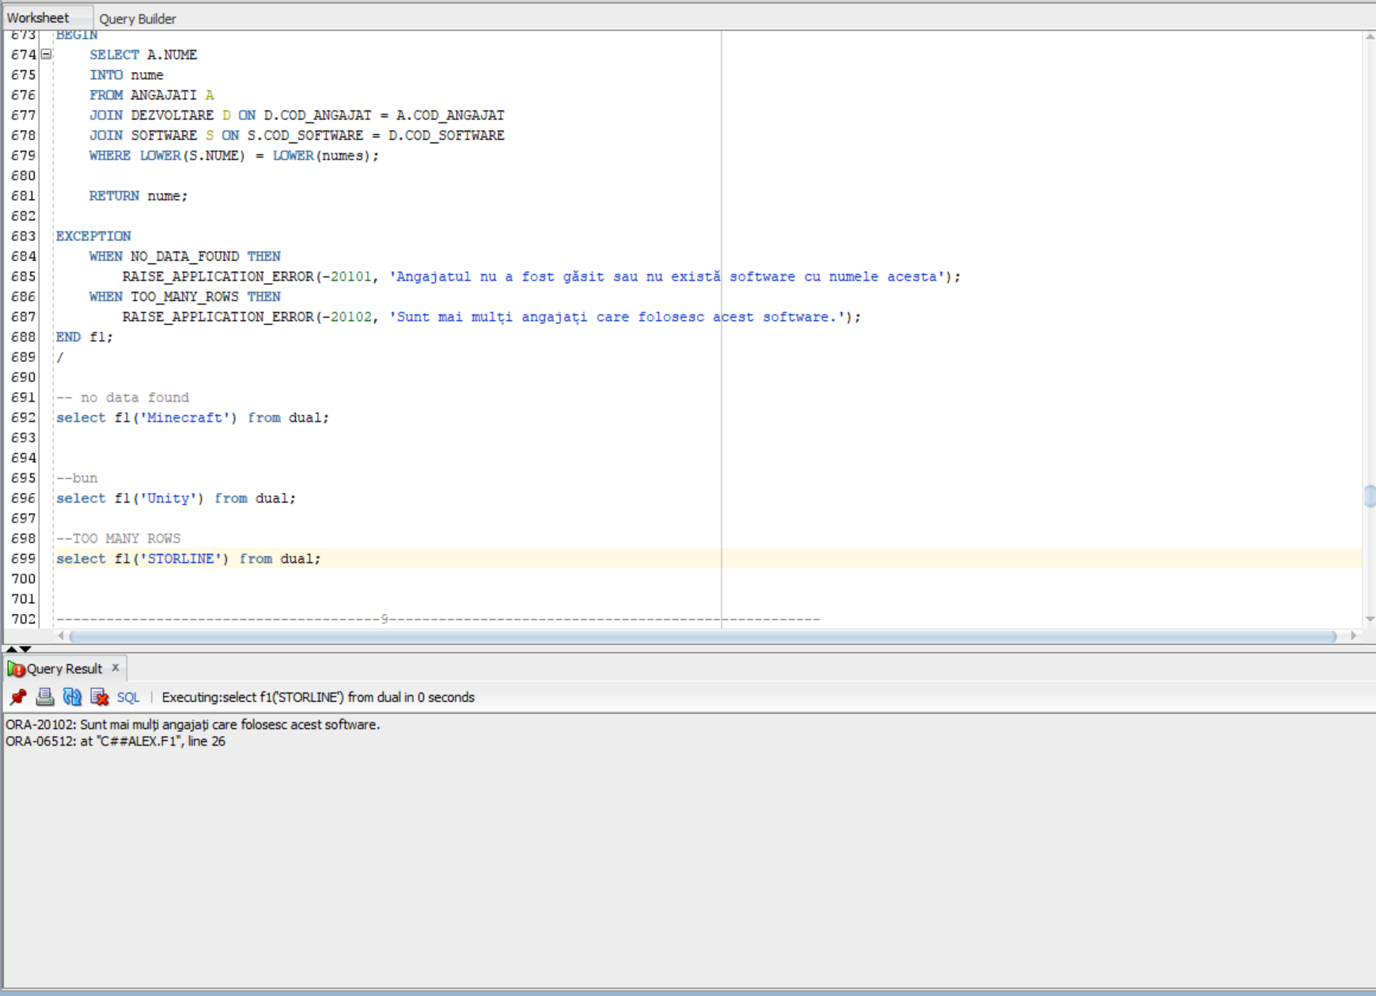

# 9. Formulati in limbaj natural o problema pe care sa o rezolvati folosind un subprogram stocat independent de tip procedura care sa utilizeze intr-o singura comanda SQL 5 dintre tabelele definite. Tratati toate exceptiile care pot aparea, incluzând exceptiile NO_DATA_FOUND si TOO_MANY_ROWS. Apelati subprogramul astfel incât sa evidentiati toate cazurile tratate.

Primind regiunea ,unui server, si numele ,unui software, afisati numele , prenumele ,salariul angajatului care a folosit software-ul ca sa creeze un joc ce are un server in regiunea data , afisati si numele jocului creat. Daca nu exista un joc / angajat care indeplinesc condtiile sau daca sunt mai multe raspunsuri se vor tratra exceptiile .

CREATE OR REPLACE PROCEDURE primul (

p_regiune IN servere.regiune%TYPE,

p_nume_software IN software.nume%TYPE

) AS

nume angajati.nume%TYPE;

prenume angajati.prenume%TYPE;

salariu angajati.salariu%TYPE;

nume_joc jocuri.nume%TYPE;

BEGIN

SELECT a.nume, a.prenume, a.salariu, j.nume

INTO nume, prenume, salariu, nume_joc

FROM jocuri j

JOIN dezvoltare d ON d.cod_joc = j.cod_joc

JOIN angajati a ON a.cod_angajat = d.cod_angajat

JOIN software s ON s.cod_software = d.cod_software

JOIN servere se ON se.cod_joc = j.cod_joc

WHERE LOWER(se.regiune) = LOWER(p_regiune)

AND LOWER(s.nume) = LOWER(p_nume_software)

ORDER BY a.salariu DESC;

DBMS_OUTPUT.PUT_LINE('Nume: ' || nume);

DBMS_OUTPUT.PUT_LINE('Prenume: ' || prenume);

DBMS_OUTPUT.PUT_LINE('Salariu: ' || salariu);

DBMS_OUTPUT.PUT_LINE('Nume Joc: ' || nume_joc);

EXCEPTION

WHEN NO_DATA_FOUND THEN

DBMS_OUTPUT.PUT_LINE('Nu s-au gasit date pentru regiunea si software-ul specificate.');

WHEN TOO_MANY_ROWS THEN

DBMS_OUTPUT.PUT_LINE('Exista mai multe inregistrari decat era de asteptat.');

WHEN OTHERS THEN

DBMS_OUTPUT.PUT_LINE('O eroare neasteptata a aparut: ' || SQLERRM);

END primul;

/

------no data

begin

primul('europa','storyline');

end;

/

--Exista mai multe inregistrari

begin

primul('europa','storline');

end;

/

--bun

begin

primul('europa','unity');

end;

/

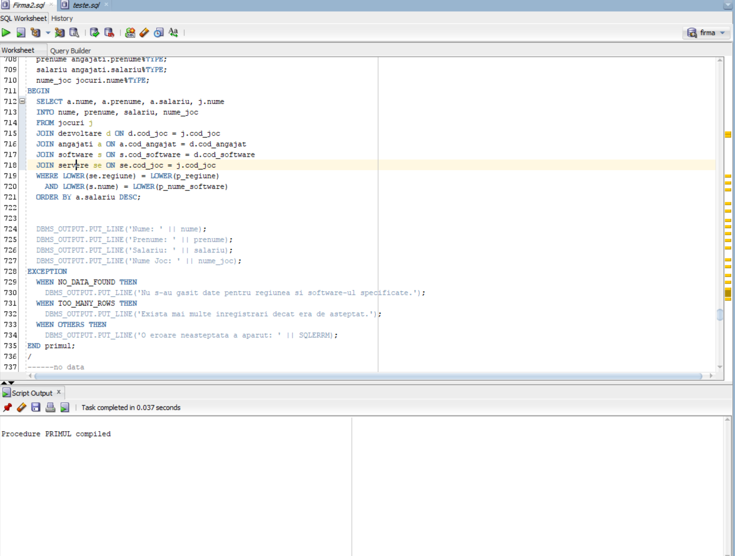

No data

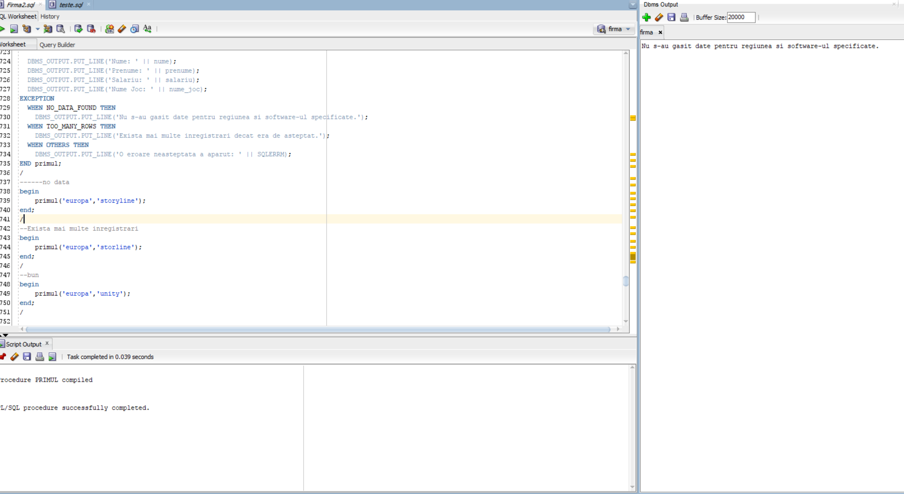

Too many rows.

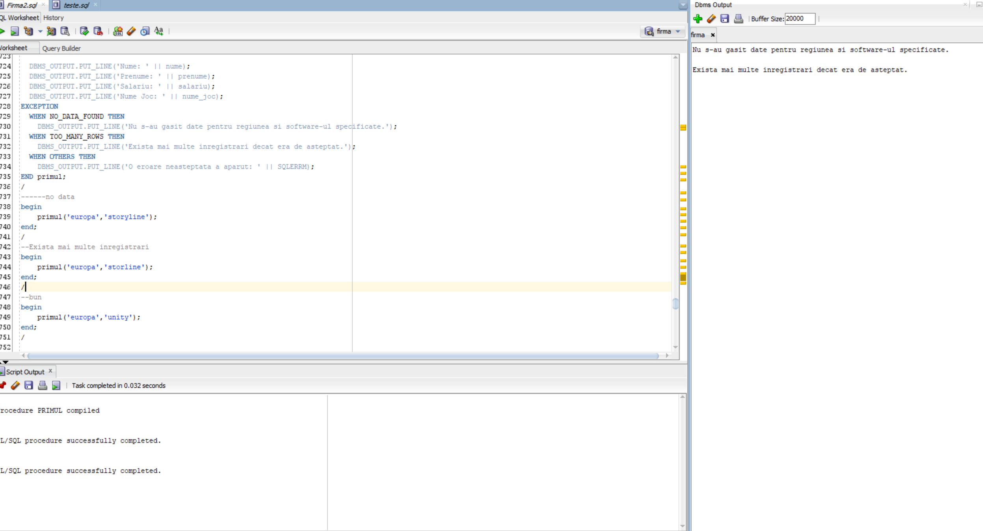

Bun

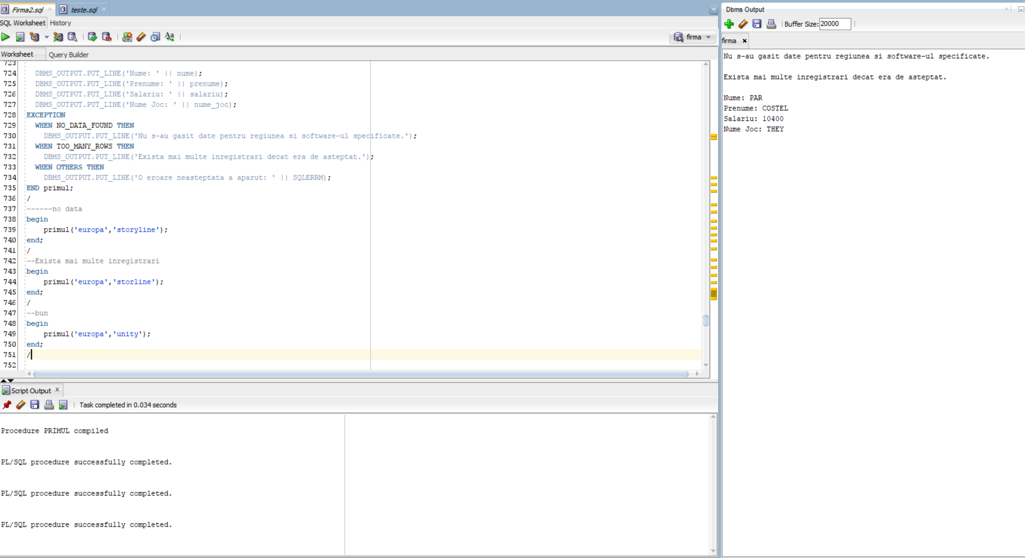

# 10. Definiti un trigger de tip LMD la nivel de comanda. Declansati trigger-ul.

CREATE OR REPLACE TRIGGER limitare_departament_juridic

BEFORE INSERT ON departament_juridic

DECLARE

nr NUMBER;

BEGIN

SELECT COUNT(*)

INTO nr

FROM departament_juridic;

IF nr >= 15 THEN

RAISE_APPLICATION_ERROR(-20001, 'Numarul maxim de inregistrari in tabelul DEPARTAMENT_JURIDIC a fost atins.');

END IF;

END;

/

DECLARE

BEGIN

INSERT INTO departament_juridic (COD_ANGAJAT, COD_CAZ, COD_MANAGER)

VALUES (0,3, 0);

COMMIT;

EXCEPTION

WHEN OTHERS THEN

DBMS_OUTPUT.PUT_LINE('Eroare: ' || SQLERRM);

ROLLBACK;

END;

/

drop trigger limitare_departament_juridic;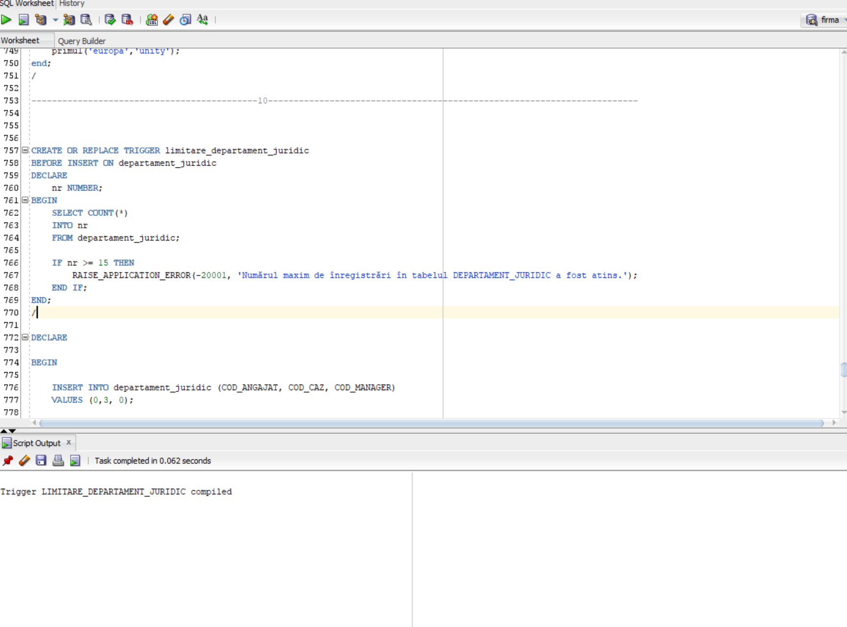

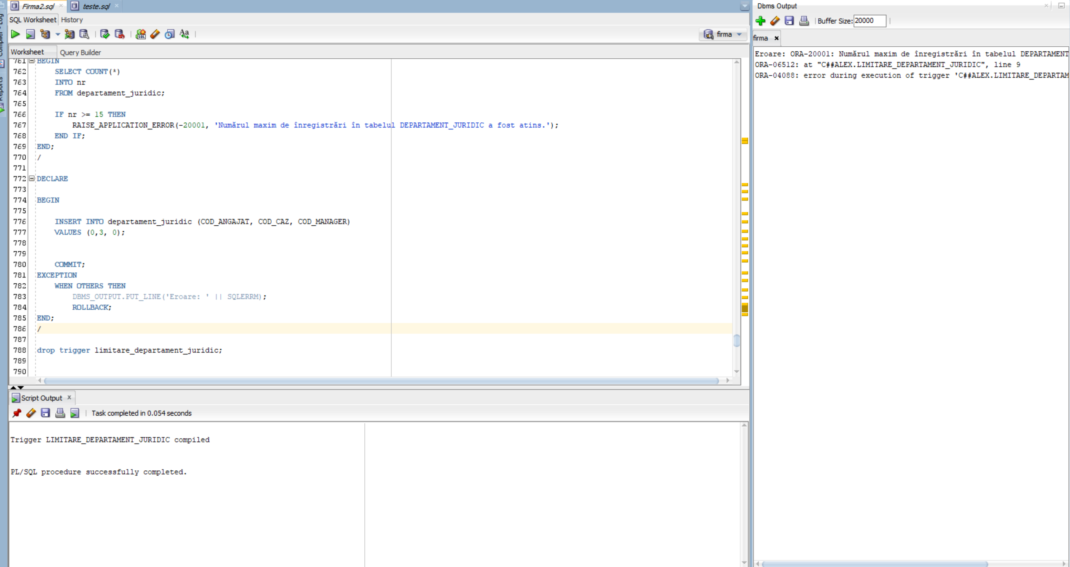

# 11. Definiti un trigger de tip LMD la nivel de linie. Declansati trigger-ul.

CREATE OR REPLACE TRIGGER limita_salariu

BEFORE INSERT ON ANGAJATI

FOR EACH ROW

DECLARE

v_limita_salariu NUMBER := 10000; -- Setati limita salariului aici

BEGIN

IF :NEW.salariu > v_limita_salariu THEN

RAISE_APPLICATION_ERROR(-20001, 'Salariul nu poate depasi ' || v_limita_salariu || '.');

END IF;

END;

/

INSERT INTO ANGAJATI (COD_ANGAJAT, NUME, PRENUME, EMAIL, DATA_NASTERE, DATA_ANGAJARE, TELEFON, COD_MANAGER, salariu)

VALUES (1000, 'Nume1', 'Prenume1', 'email1@example.com', TO_DATE('1990-01-01', 'YYYY-MM-DD'), SYSDATE, '123456789', 987, 15000);

drop trigger limita_salariu;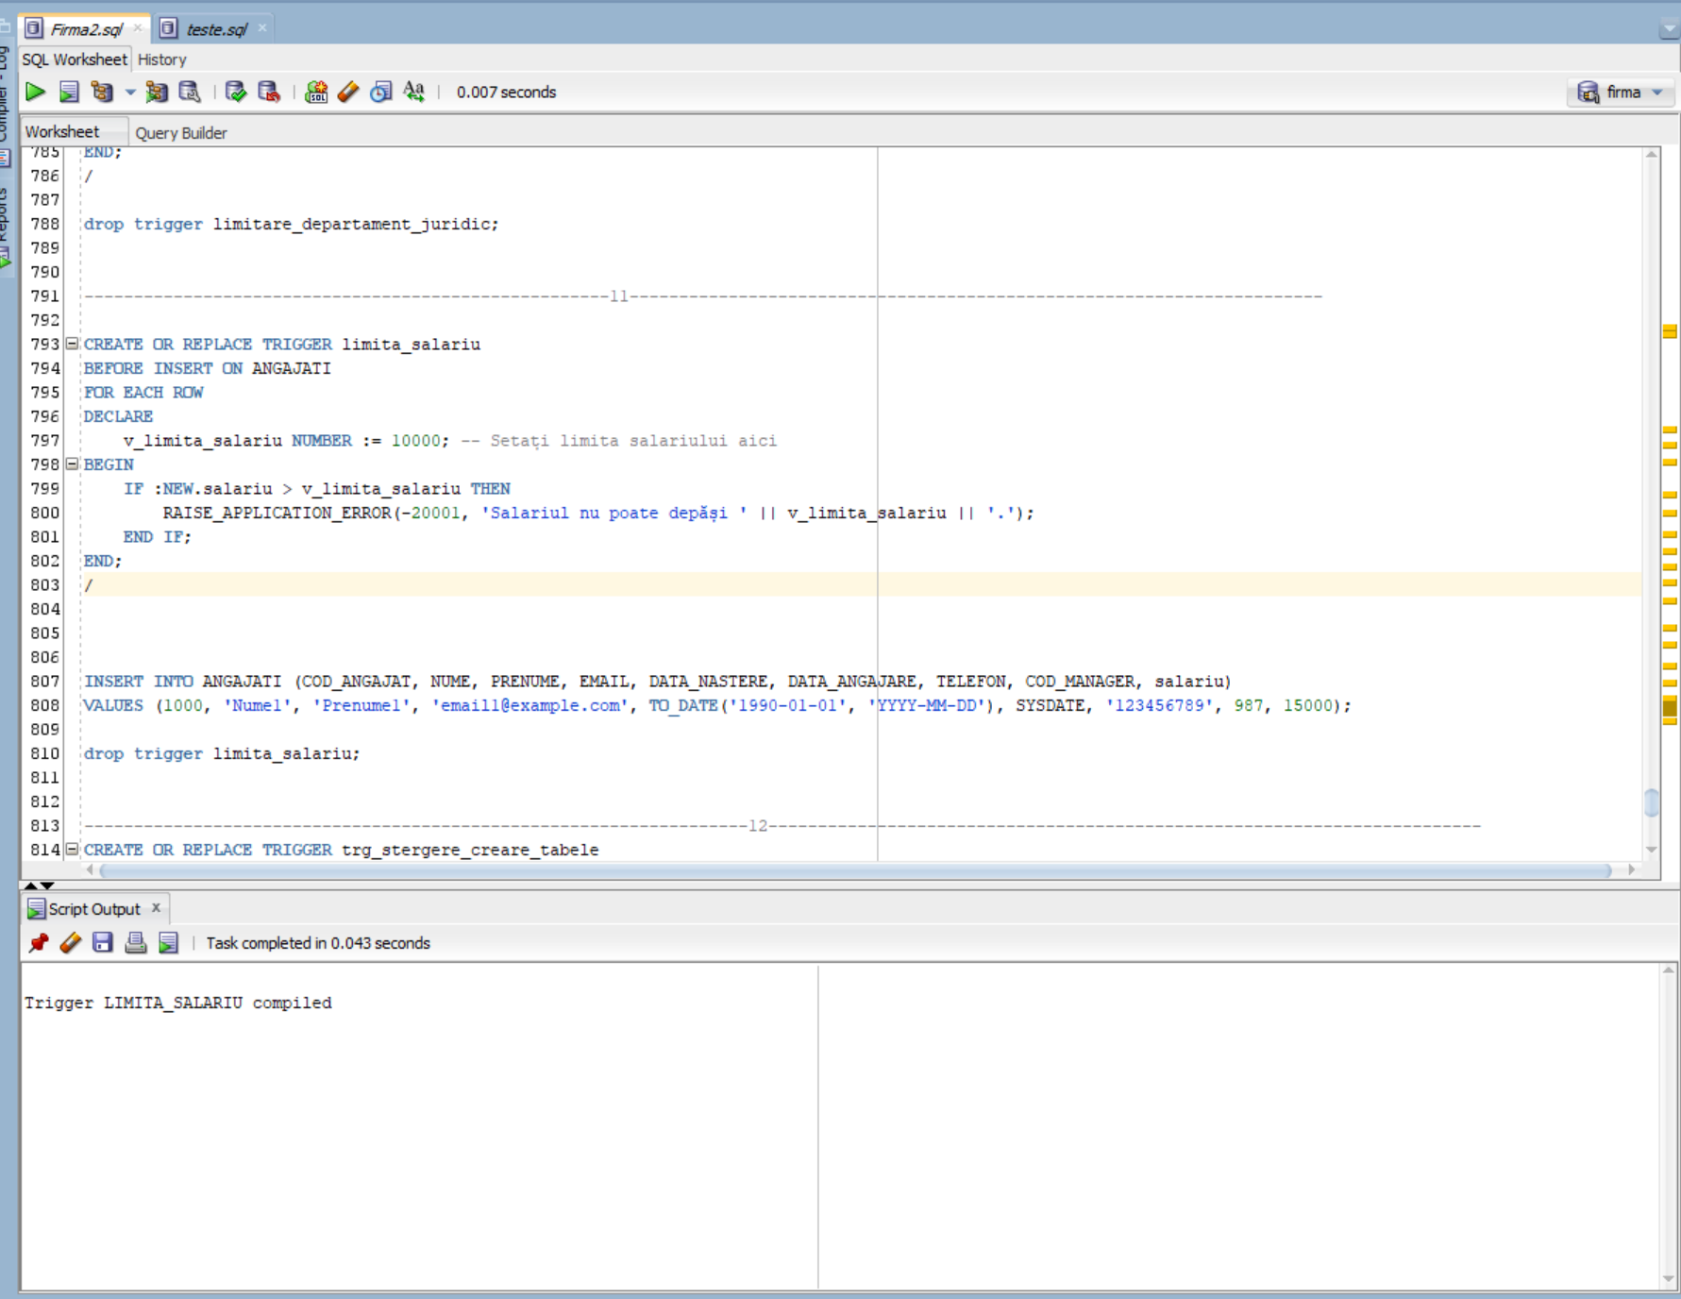

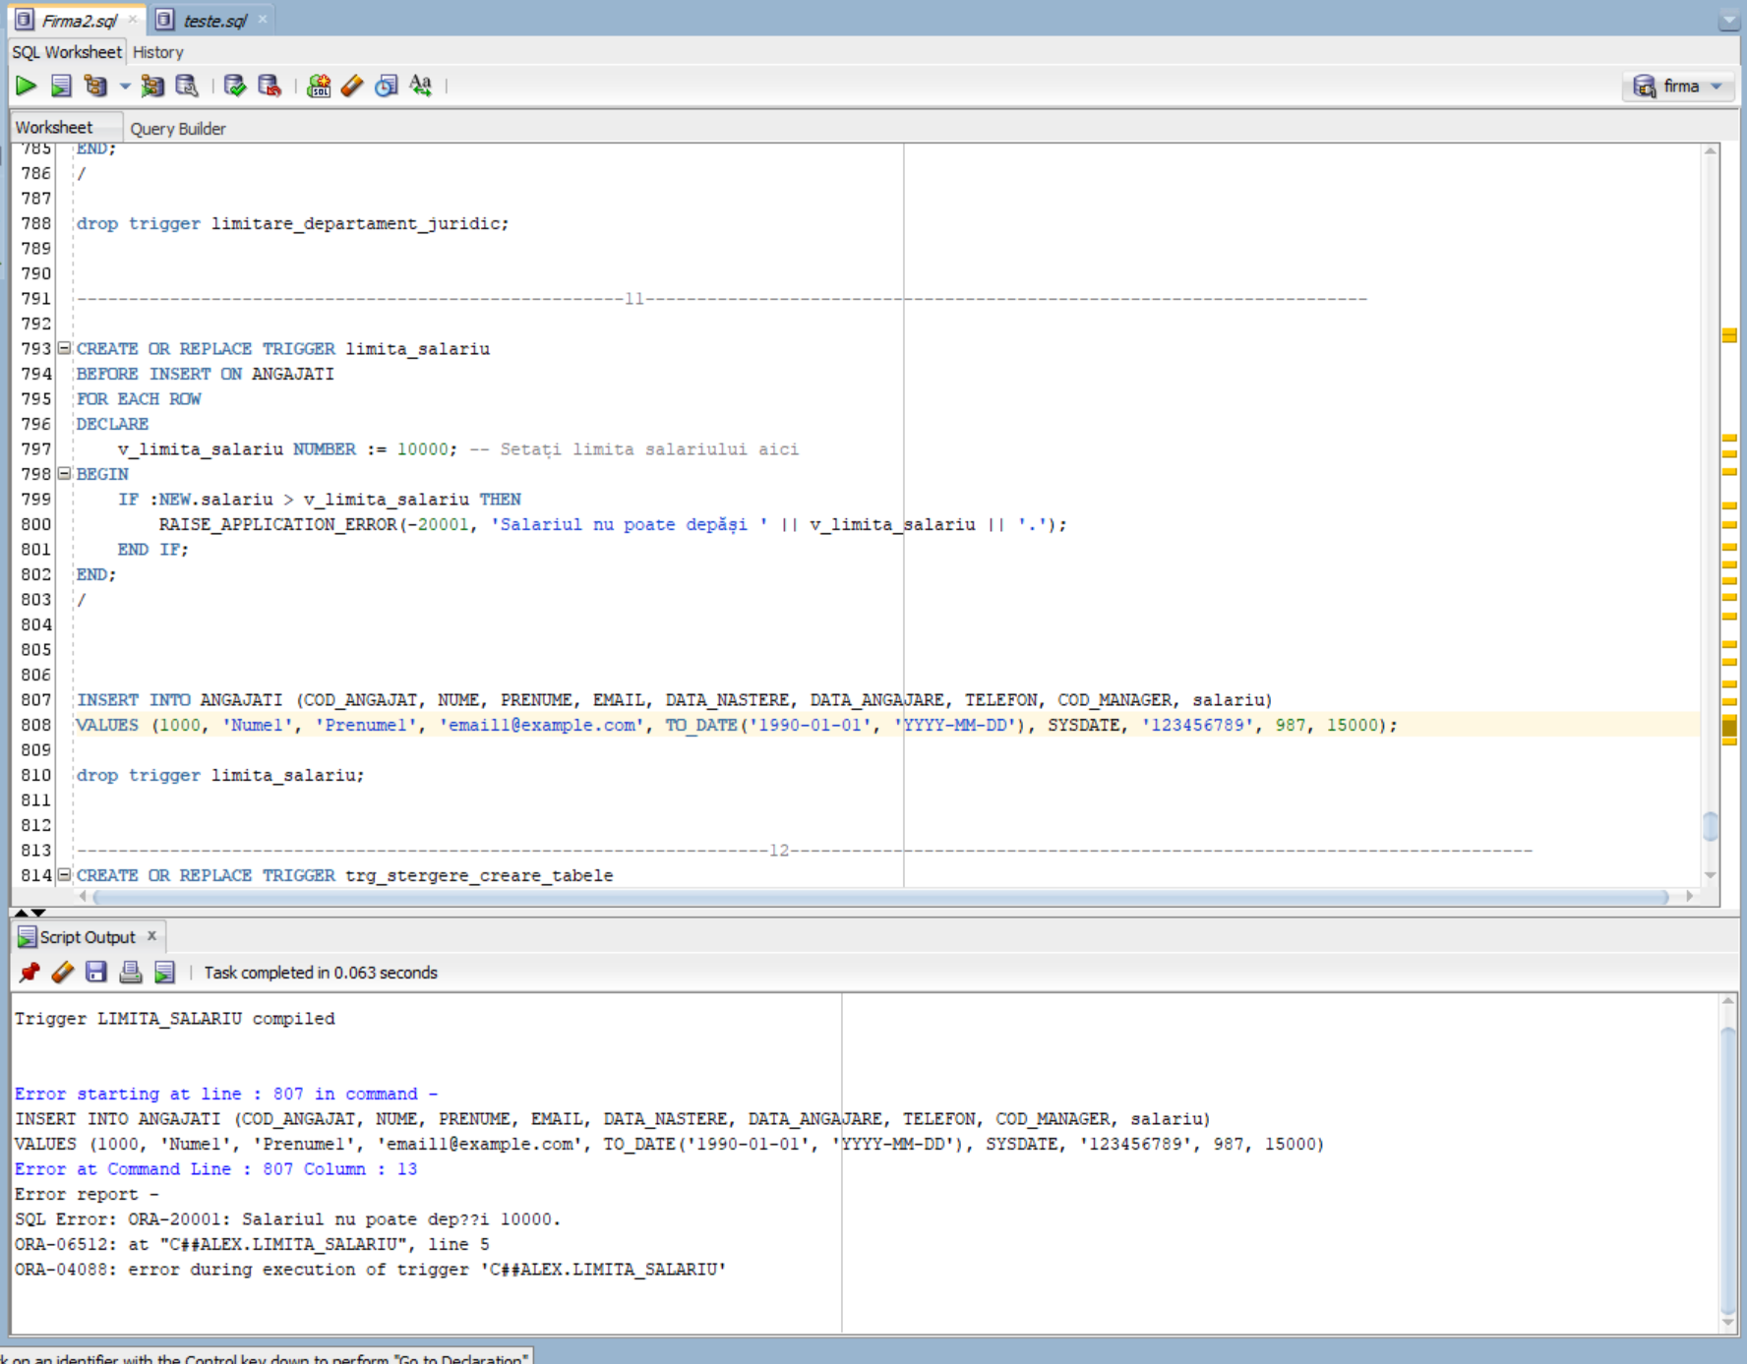

# 12. Definiti un trigger de tip LDD. Declansati trigger-ul.

CREATE OR REPLACE TRIGGER trg_stergere_creare_tabele

BEFORE CREATE OR DROP ON DATABASE

DECLARE

v_username VARCHAR2(30);

BEGIN

SELECT SYS_CONTEXT('USERENV', 'CURRENT_USER') INTO v_username FROM DUAL;

IF v_username = 'C##ALEX' THEN

RAISE_APPLICATION_ERROR(-20001, 'Nu aveti permisiunea sa creati sau sa stergeti tabele in baza de date.');

END IF;

END trg_stergere_creare_tabele;

/

CREATE TABLE TestTable (

ID NUMBER,

NAME VARCHAR2(50)

);

drop trigger trg_stergere_creare_tabele;

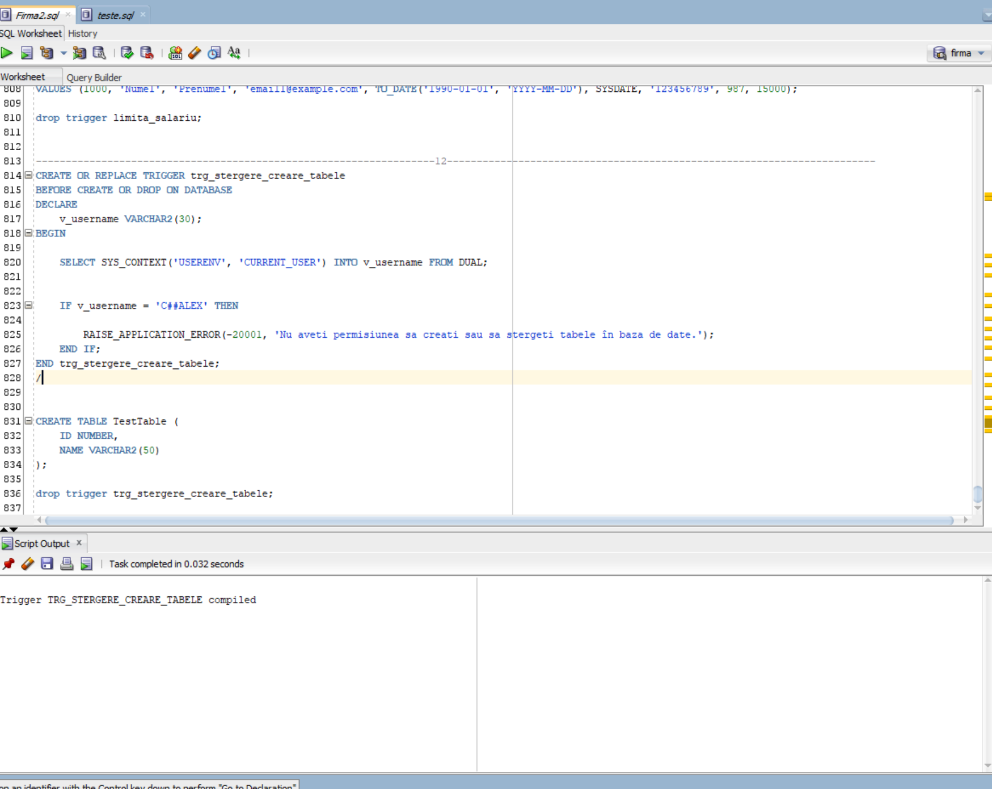

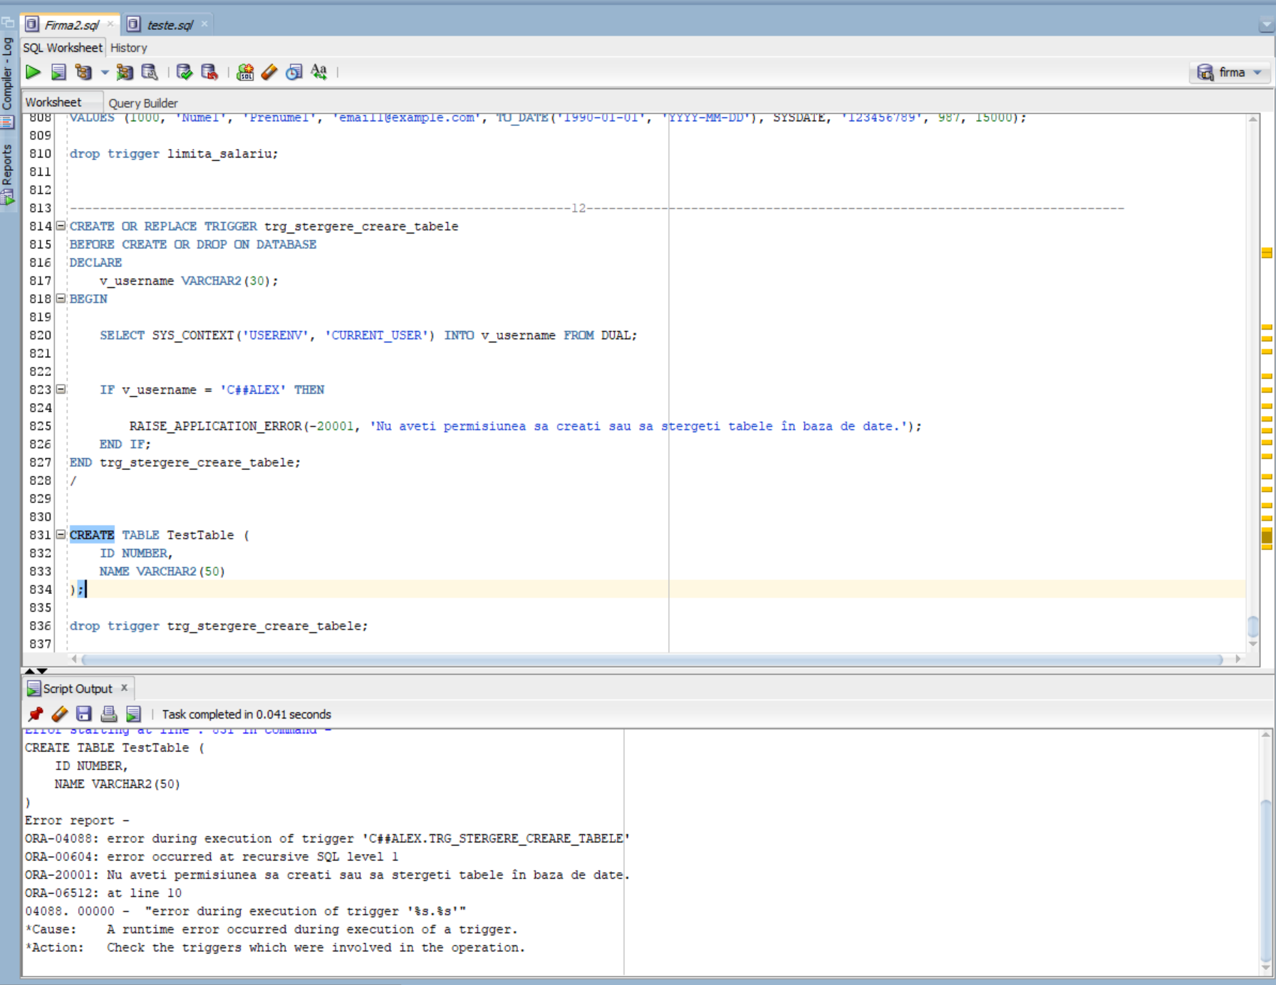

# 13. Definiti un pachet care sa contina toate obiectele definite in cadrul proiectului.

create or replace PACKAGE p13 as

--6

PROCEDURE afisare (id_joc JOCURI.COD_JOC%TYPE);

--7

PROCEDURE GestionareEchipeDezvoltare (COD_JOC_IN IN JOCURI.COD_JOC%TYPE);

--8

FUNCTION f1(numes software.nume%type) return angajati.nume%type;

--9

PROCEDURE primul (p_regiune IN servere.regiune%TYPE,p_nume_software IN software.nume%TYPE);

end p13;

/

create or replace PACKAGE BODY p13 as

--6

PROCEDURE afisare (id_joc JOCURI.COD_JOC%TYPE) AS

TYPE ServereIndexate IS TABLE OF SERVERE%ROWTYPE INDEX BY PLS_INTEGER;

v_servere_indexate ServereIndexate;

TYPE TesteImbatabile IS TABLE OF REZULTATE_TESTE%ROWTYPE INDEX BY PLS_INTEGER;

v_teste_imbatabile TesteImbatabile;

TYPE SoftwareVector IS VARRAY(100) OF DEZVOLTARE.COD_SOFTWARE%TYPE;

v_software_vector SoftwareVector := SoftwareVector();

contor NUMBER := 1;

nume software.nume%type;

BEGIN

select nume into nume from jocuri where cod_joc = id_joc;

DBMS_OUTPUT.PUT_LINE('Jocul este: ' || '' || nume);

-- Afi?are ?i salvare servere in tabel indexat

FOR server_rec IN (SELECT * FROM SERVERE WHERE COD_JOC = id_joc) LOOP

v_servere_indexate(contor) := server_rec;

contor := contor + 1;

END LOOP;

-- Afi?are ?i salvare teste in tabel indexat

contor := 1;

FOR teste_rec IN (SELECT * FROM REZULTATE_TESTE WHERE COD_JOC = id_joc) LOOP

v_teste_imbatabile(contor) := teste_rec;

contor := contor + 1;

END LOOP;

-- Afi?are ?i salvare software in vector

contor := 1;

FOR software_rec IN (SELECT DISTINCT COD_SOFTWARE FROM DEZVOLTARE WHERE COD_JOC = id_joc) LOOP

v_software_vector.EXTEND;

v_software_vector(contor) := software_rec.COD_SOFTWARE;

contor := contor + 1;

END LOOP;

-- Afi?are rezultate

DBMS_OUTPUT.PUT_LINE('Servere in tabel indexat: ');

FOR i IN 1..v_servere_indexate.COUNT LOOP

DBMS_OUTPUT.PUT_LINE(v_servere_indexate(i).COD_SERVER || ' - ' || v_servere_indexate(i).REGIUNE || ' - ' || v_servere_indexate(i).CAPACITATE_MAXIMA);

END LOOP;

DBMS_OUTPUT.PUT_LINE('Teste in tabel indexat:');

FOR i IN 1..v_teste_imbatabile.COUNT LOOP

DBMS_OUTPUT.PUT_LINE(v_teste_imbatabile(i).COD_TEST || ' - ' || v_teste_imbatabile(i).NOTA_TEST);

END LOOP;

DBMS_OUTPUT.PUT_LINE('Software in vector:' );

FOR i IN 1..v_software_vector.COUNT LOOP

select nume into nume from software where cod_software = v_software_vector(i);

DBMS_OUTPUT.PUT_LINE(v_software_vector(i) || ' - ' || nume);

END LOOP;

END;

--7

PROCEDURE GestionareEchipeDezvoltare (COD_JOC_IN IN JOCURI.COD_JOC%TYPE) AS

CURSOR CurAngajati IS

SELECT A.COD_ANGAJAT, A.NUME, A.PRENUME, D.COD_JOC, D.COD_SOFTWARE

FROM ANGAJATI A

JOIN DEZVOLTARE D ON A.COD_ANGAJAT = D.COD_ANGAJAT

WHERE D.COD_JOC = COD_JOC_IN;

CURSOR CurSoftware (COD_SOFTWARE_IN IN SOFTWARE.COD_SOFTWARE%TYPE) IS

SELECT NUME, UTILIZARE

FROM SOFTWARE

WHERE COD_SOFTWARE = COD_SOFTWARE_IN;

nume_ANGAJAT ANGAJATI.NUME%TYPE;

prenume_ANGAJAT ANGAJATI.PRENUME%TYPE;

nume_SOFTWARE SOFTWARE.NUME%TYPE;

V_UTILIZARE_SOFTWARE SOFTWARE.UTILIZARE%TYPE;

BEGIN

FOR RecAngajat IN CurAngajati LOOP

nume_ANGAJAT := RecAngajat.NUME;

prenume_ANGAJAT := RecAngajat.PRENUME;

FOR RecSoftware IN CurSoftware(RecAngajat.COD_SOFTWARE) LOOP

nume_SOFTWARE := RecSoftware.NUME;

V_UTILIZARE_SOFTWARE := RecSoftware.UTILIZARE;

DBMS_OUTPUT.PUT_LINE('Angajat: ' || nume_ANGAJAT || ' ' || prenume_ANGAJAT);

DBMS_OUTPUT.PUT_LINE('Software Utilizat: ' || nume_SOFTWARE || ' - ' || V_UTILIZARE_SOFTWARE);

DBMS_OUTPUT.PUT_LINE('---');

END LOOP;

END LOOP;

END GestionareEchipeDezvoltare;

--8

FUNCTION f1(

numes SOFTWARE.NUME%TYPE

) RETURN ANGAJATI.NUME%TYPE

IS

nume ANGAJATI.NUME%TYPE;

AngajatNotFound EXCEPTION;

PRAGMA EXCEPTION_INIT(AngajatNotFound, -20101);

SoftwareInUse EXCEPTION;

PRAGMA EXCEPTION_INIT(SoftwareInUse, -20102);

BEGIN

SELECT A.NUME

INTO nume

FROM ANGAJATI A

JOIN DEZVOLTARE D ON D.COD_ANGAJAT = A.COD_ANGAJAT

JOIN SOFTWARE S ON S.COD_SOFTWARE = D.COD_SOFTWARE

WHERE LOWER(S.NUME) = LOWER(numes);

RETURN nume;

EXCEPTION

WHEN NO_DATA_FOUND THEN

RAISE_APPLICATION_ERROR(-20101, 'Angajatul nu a fost gasit sau nu exista software cu numele acesta');

WHEN TOO_MANY_ROWS THEN

RAISE_APPLICATION_ERROR(-20102, 'Sunt mai multi angajati care folosesc acest software.');

END f1;

--9

PROCEDURE primul (

p_regiune IN servere.regiune%TYPE,

p_nume_software IN software.nume%TYPE

) AS

nume angajati.nume%TYPE;

prenume angajati.prenume%TYPE;

salariu angajati.salariu%TYPE;

nume_joc jocuri.nume%TYPE;

BEGIN

SELECT a.nume, a.prenume, a.salariu, j.nume

INTO nume, prenume, salariu, nume_joc

FROM jocuri j

JOIN dezvoltare d ON d.cod_joc = j.cod_joc

JOIN angajati a ON a.cod_angajat = d.cod_angajat

JOIN software s ON s.cod_software = d.cod_software

JOIN servere se ON se.cod_joc = j.cod_joc

WHERE LOWER(se.regiune) = LOWER(p_regiune)

AND LOWER(s.nume) = LOWER(p_nume_software)

ORDER BY a.salariu DESC;

DBMS_OUTPUT.PUT_LINE('Nume: ' || nume);

DBMS_OUTPUT.PUT_LINE('Prenume: ' || prenume);

DBMS_OUTPUT.PUT_LINE('Salariu: ' || salariu);

DBMS_OUTPUT.PUT_LINE('Nume Joc: ' || nume_joc);

EXCEPTION

WHEN NO_DATA_FOUND THEN

DBMS_OUTPUT.PUT_LINE('Nu s-au gasit date pentru regiunea si software-ul specificate.');

WHEN TOO_MANY_ROWS THEN

DBMS_OUTPUT.PUT_LINE('Exista mai multe inregistrari decat era de asteptat.');

WHEN OTHERS THEN

DBMS_OUTPUT.PUT_LINE('O eroare neasteptata a aparut: ' || SQLERRM);

END primul;

end p13;

/

DECLARE

id_joc JOCURI.COD_JOC%TYPE := 6;

cod_joc_gestionare JOCURI.COD_JOC%TYPE := 1;

nume_software_f1 SOFTWARE.NUME%TYPE := 'Unity';

regiune_primul SERVERE.REGIUNE%TYPE := 'Regiune1';

nume_angajat_f1 ANGAJATI.NUME%TYPE;

BEGIN

p13.afisare(id_joc);

p13.GestionareEchipeDezvoltare(cod_joc_gestionare);

nume_angajat_f1 := p13.f1(nume_software_f1);

DBMS_OUTPUT.PUT_LINE('Numele angajatului care foloseste ' || nume_software_f1 || ': ' || nume_angajat_f1);

p13.primul('europa','unity');

END;

/

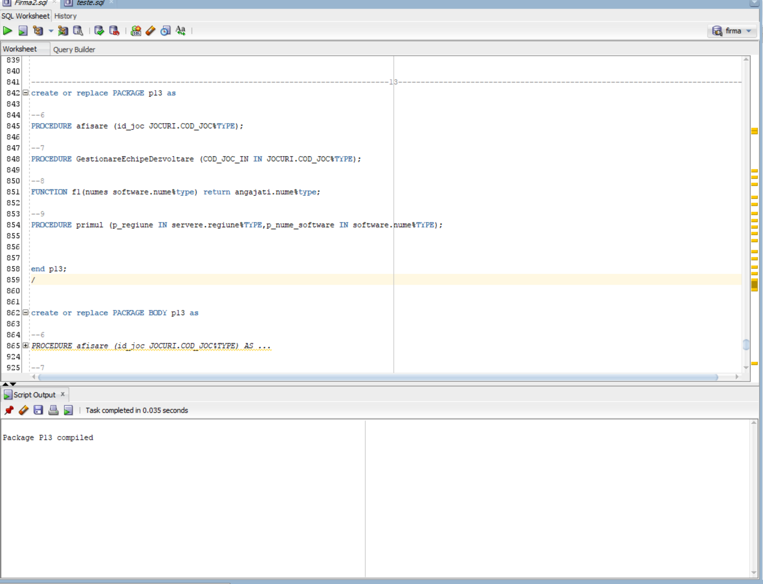 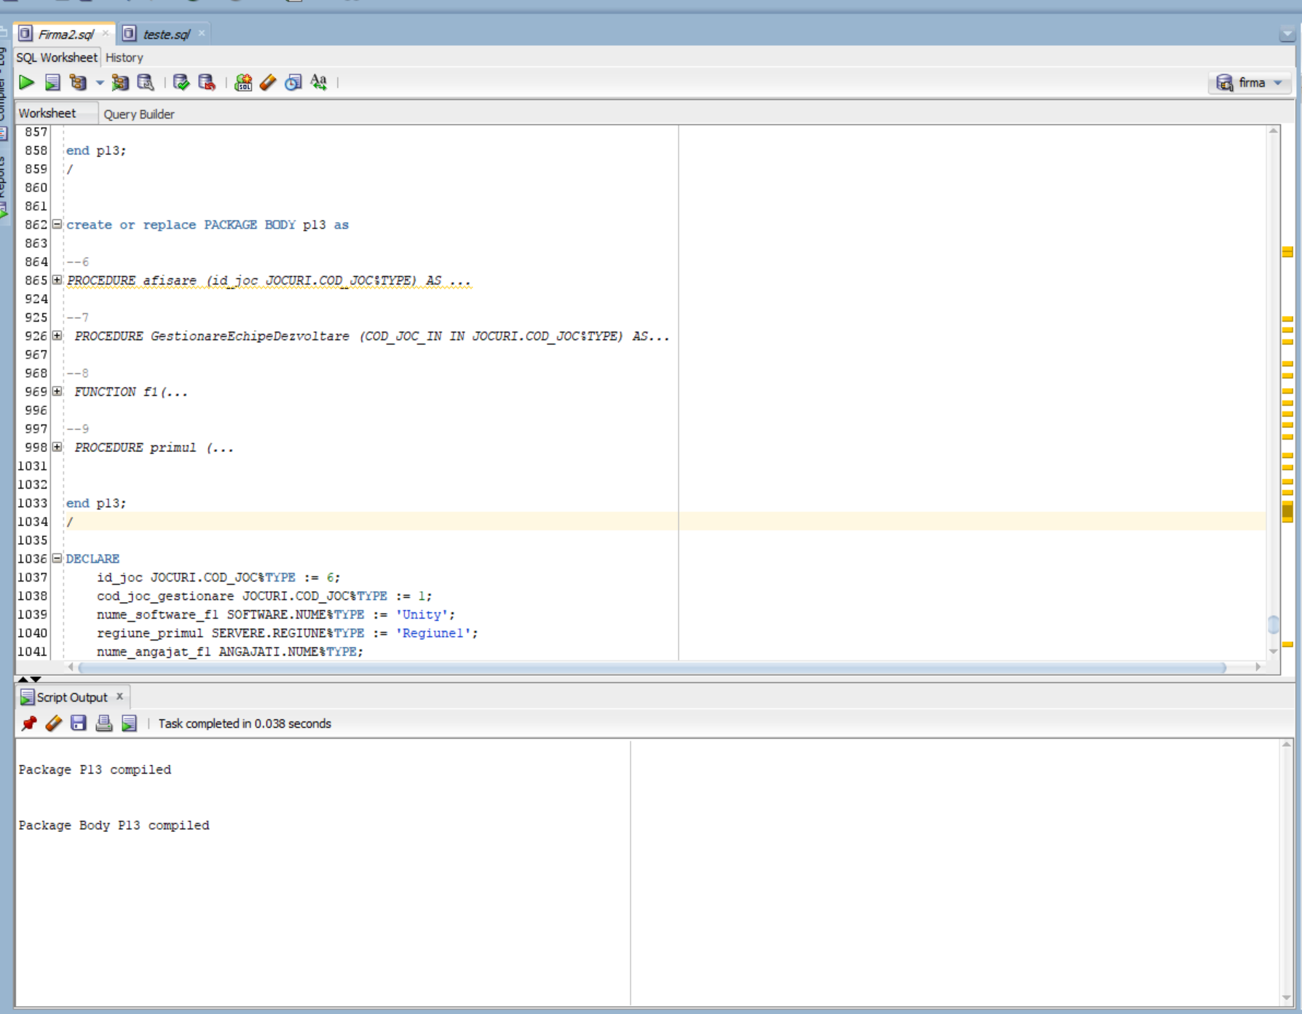

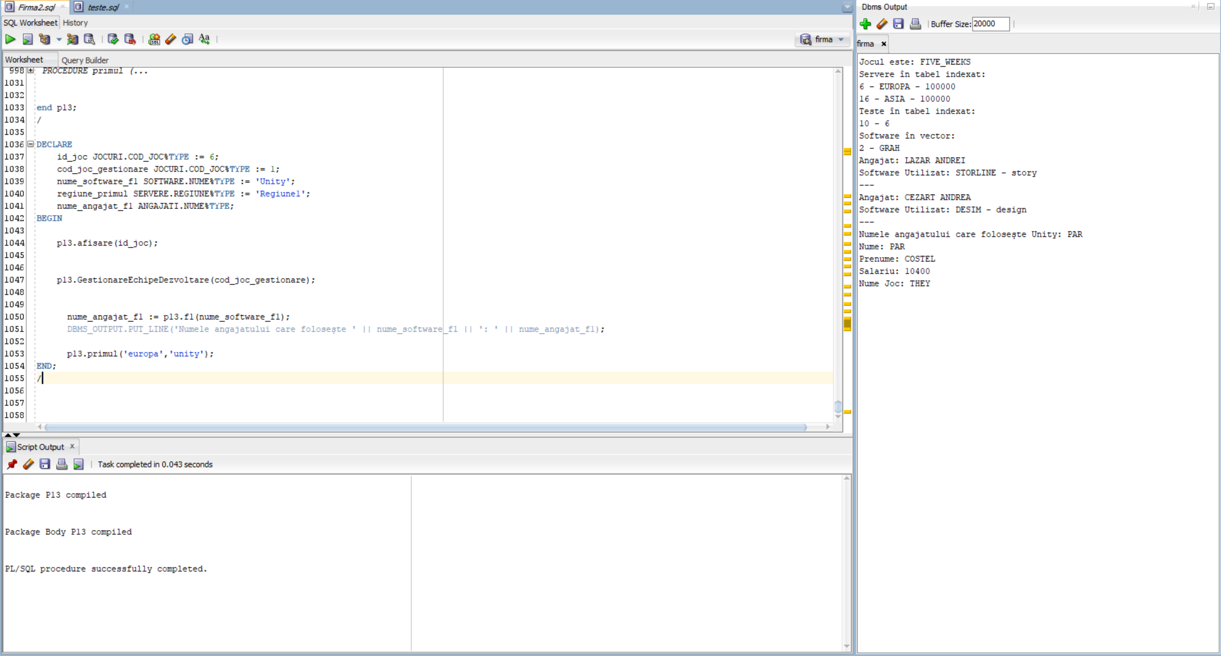

# 14. Definiti un pachet care sa includa tipuri de date complexe si obiecte necesare unui flux de actiuni integrate, specifice bazei de date definite (minim 2 tipuri de date, minim 2 functii, minim 2 proceduri).

CREATE OR REPLACE PACKAGE p14 AS

TYPE AngajatType IS RECORD (

Cod_Angajat NUMBER,

Nume VARCHAR2(25),

Prenume VARCHAR2(25),

Email VARCHAR2(225),

Data_Nastere DATE,

Data_Angajare DATE,

Telefon NUMBER,

Cod_Manager NUMBER,

Salariu NUMBER

);

TYPE TestType IS RECORD (

Cod_Test NUMBER,

Cod_Joc NUMBER,

Cod_Angajat NUMBER,

Data_Test DATE,

Nota_Test NUMBER,

Descriere_Probleme VARCHAR2(225)

);

FUNCTION CalculSalariuMediuRegiune(regiune servere.regiune%type) RETURN NUMBER;

FUNCTION ObtineAngajat(Cod_Angajats angajati.cod_angajat%type) RETURN AngajatType;

PROCEDURE ActualizeazaSalariuAngajat(Cod_Angajat angajati.cod_angajat%type, NouSalariu angajati.salariu%type);

PROCEDURE InregistreazaTest(Test TestType);

END p14;

/

CREATE OR REPLACE PACKAGE BODY p14 AS

FUNCTION CalculSalariuMediuRegiune(regiune servere.regiune%type) RETURN NUMBER IS

AvgSalariu NUMBER;

BEGIN

select avg(a.salariu)

into AvgSalariu

from angajati a

join dezvoltare d on d.cod_angajat = a.cod_angajat

join servere s on s.cod_joc = d.cod_joc

where lower(s.regiune) = lower(regiune);

RETURN AvgSalariu;

END CalculSalariuMediuRegiune;

FUNCTION ObtineAngajat(Cod_Angajats angajati.cod_angajat%type) RETURN AngajatType IS

Emp AngajatType;

BEGIN

SELECT COD_ANGAJAT, NUME, PRENUME, EMAIL, DATA_NASTERE, DATA_ANGAJARE, TELEFON, COD_MANAGER, salariu

INTO Emp.Cod_Angajat, Emp.Nume, Emp.Prenume, Emp.Email, Emp.Data_Nastere, Emp.Data_Angajare, Emp.Telefon, Emp.Cod_Manager, Emp.Salariu

FROM ANGAJATI

WHERE COD_ANGAJAT = Cod_Angajats AND ROWNUM = 1;

RETURN Emp;

EXCEPTION

WHEN NO_DATA_FOUND THEN

RAISE_APPLICATION_ERROR(-20001, 'Angajatul nu a fost gasit.');

END ObtineAngajat;

PROCEDURE ActualizeazaSalariuAngajat(Cod_Angajat ANGAJATI.COD_ANGAJAT%TYPE, NouSalariu ANGAJATI.salariu%TYPE) IS

BEGIN

UPDATE ANGAJATI

SET salariu = NouSalariu

WHERE COD_ANGAJAT = Cod_Angajat;

COMMIT;

END ActualizeazaSalariuAngajat;

PROCEDURE InregistreazaTest(Test TestType) IS

BEGIN

INSERT INTO REZULTATE_TESTE (COD_TEST, COD_JOC, COD_ANGAJAT, DATA_TEST, NOTA_TEST, DESCRIERE_PROBLEME)

VALUES (Test.COD_TEST, Test.COD_JOC, Test.COD_ANGAJAT, Test.DATA_TEST, Test.NOTA_TEST, Test.DESCRIERE_PROBLEME);

COMMIT;

END InregistreazaTest;

END p14;

/

DECLARE

avg_salariu NUMBER;

v_cod_angajat angajati.cod_angajat%TYPE := 13;

v_angajat p14.AngajatType;

v_cod_angajat_actualizare angajati.cod_angajat%TYPE := 0;

v_nou_salariu angajati.salariu%TYPE := 5000000;

v_test p14.TestType;

BEGIN

avg_salariu := p14.CalculSalariuMediuRegiune('europa');

DBMS_OUTPUT.PUT_LINE('Salariul mediu in regiunea ' || 'EUROPA' || ': ' || avg_salariu);

v_angajat := p14.ObtineAngajat(v_cod_angajat);

DBMS_OUTPUT.PUT_LINE('Nume: ' || v_angajat.Nume || ', Prenume: ' || v_angajat.Prenume || ', Email: ' || v_angajat.Email);

p14.ActualizeazaSalariuAngajat(v_cod_angajat_actualizare, v_nou_salariu);

DBMS_OUTPUT.PUT_LINE('Salariu actualizat cu succes pentru angajatul cu COD_ANGAJAT ' || v_cod_angajat_actualizare);

v_test.COD_TEST := 11;

v_test.COD_JOC := 1;

v_test.COD_ANGAJAT := 37;

v_test.DATA_TEST := TO_DATE('2024-01-12', 'YYYY-MM-DD');

v_test.NOTA_TEST := 9;

v_test.DESCRIERE_PROBLEME := 'Fara probleme dar mai trebuie lucrat la meniu';

p14.InregistreazaTest(v_test);

DBMS_OUTPUT.PUT_LINE('Test inregistrat cu succes pentru COD_TEST ' || v_test.COD_TEST);

END;

/

DELETE FROM REZULTATE_TESTE

WHERE COD_TEST = 11;

